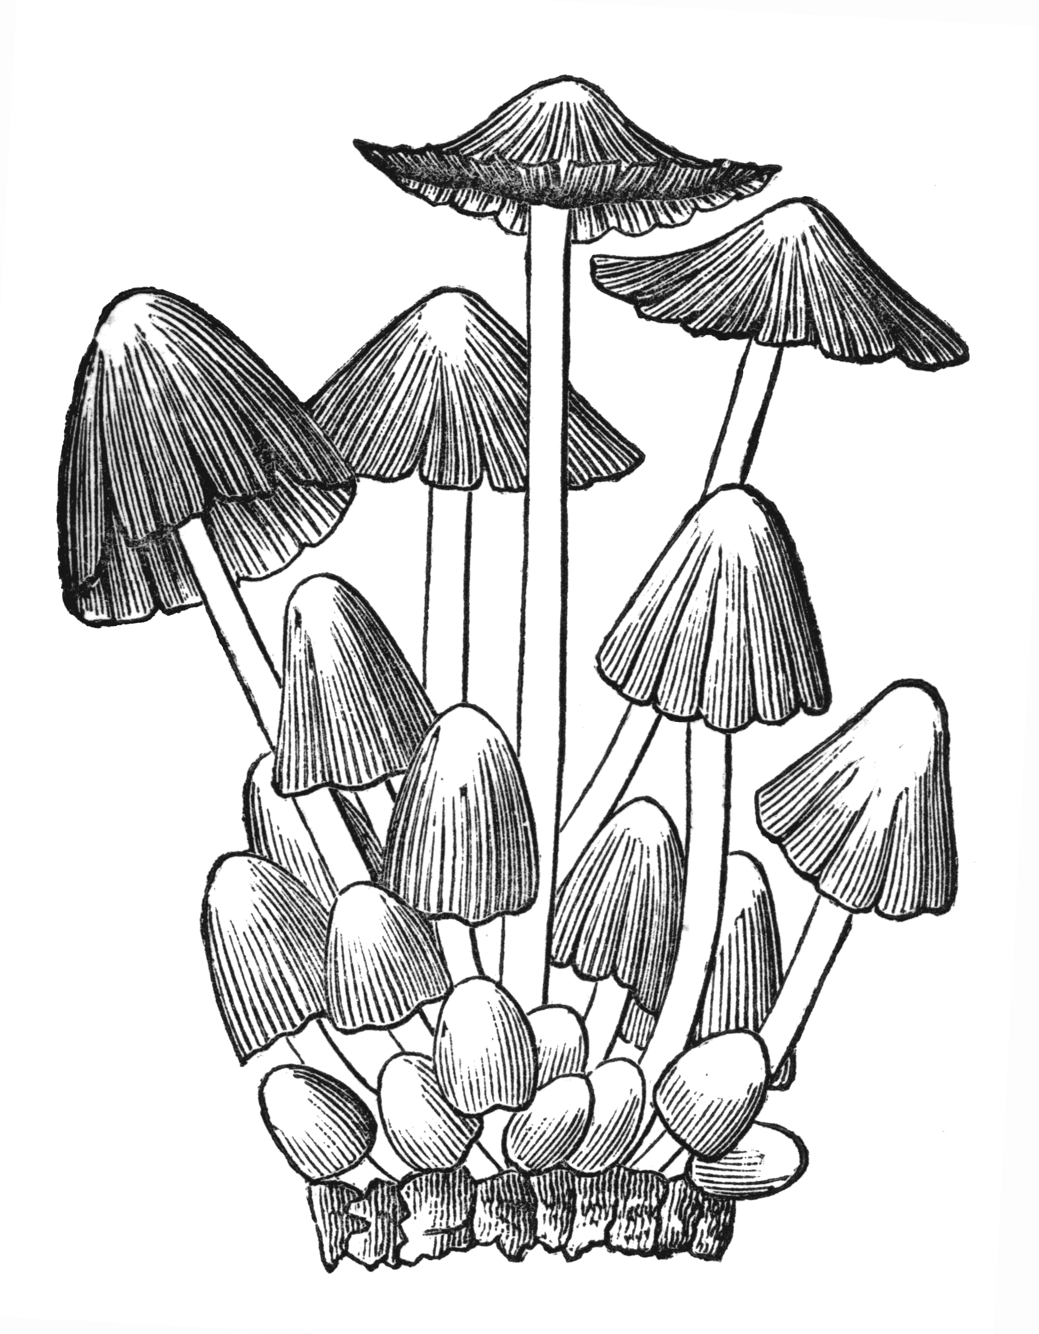
BFG
Buckinghamshire
Fungus Group

Newsletter No. 9

September 2008

£3.00 to non-members

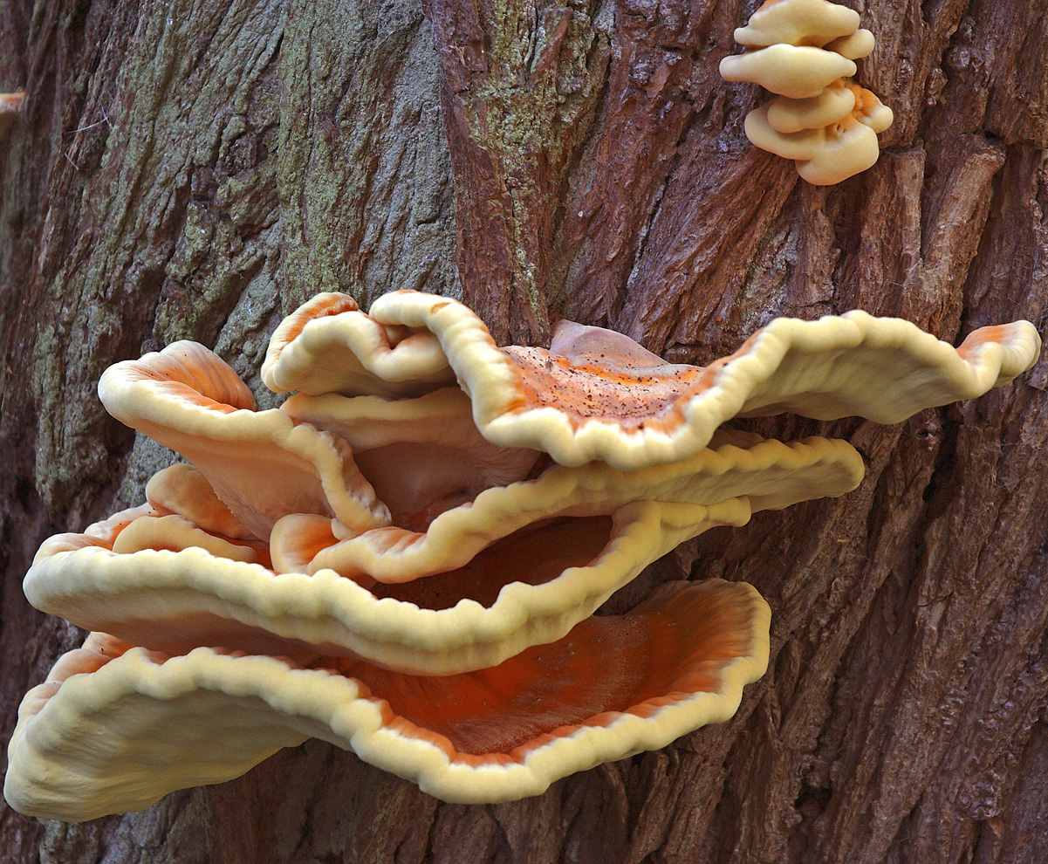

The BFG Newsletter is published annually in August or September by the Buckinghamshire Fungus Group. The group was established in 1998 with the aim of: encouraging and carrying out the recording of fungi in Buckinghamshire and elsewhere; encouraging those with an interest in fungi and assisting in expanding their knowledge; generally promoting the study and conservation of fungi and their habitats.
Secretary and Joint Recorder Derek Schafer
Newsletter Editor and Joint Recorder Penny Cullington

The Group can be contacted at fungi@bucksfungusgroup.org.uk or at the address on the back page of the Newsletter. The web site, kindly provided by the Buckinghamshire and Milton Keynes Environmental Records Centre, is www.bucksmkerc.org.uk/local_groups/fungusgroup.htm

Membership costs £4.50 a year for a single member, £6 a year for families, and members receive a free copy of this Newsletter. No special expertise is required for membership, all are welcome, particularly beginners.

CONTENTS

WHERE DOES THE TIME GO? 3
SUBSCRIPTIONS AND MEMBERSHIP LISTS 3
INSURANCE AND THE BRITISH MYCOLOGICAL SOCIETY (DJS) 3
FORAY PROGRAMME 4
IDENTIFICATION SESSIONS 5
REPORT ON THE 2007/2008 SEASON (Derek Schafer) 6
ANYONE FOR A BIT OF SLIME? 23
TWO RUSSULAS NEW TO THE COUNTY 32
HERICIUM SPECIES IN BURNHAM BEECHES 35
THE DECEIVERS REVEALED 36
BRITISH MYCENAS – BRIEF DESCRIPTIONS 38
ANIMAL, VEGETABLE OR FUNGAL? 40
FUNGUS FEASTING (Joanna Dodsworth and Roger Wilding) 41
INOCYBES, PLEASE! 42
TREES – LATIN TO ENGLISH 43
MOTIF ON THE FRONT COVER (Derek Schafer) 44
Articles written by Penny Cullington except where otherwise indicated. Photo credits: AH = Alan Hills; DJS = Derek Schafer; KR = Kerry Robinson; PC = Penny Cullington; JD = Joanna Dodsworth

Cover photo: Laetiporus sulphureus (Chicken of the Woods) growing on an old willow tree in Whitchurch September 2005 (DJS)
WHERE DOES THE TIME GO?

It seems no time at all since I was putting pen to paper (or more literally finger to keyboard) this time last year, bemoaning the previous year’s poor autumn fruiting and hoping for better things in ’07. Unfortunately this didn’t happen, although interestingly enough the weather conditions couldn’t have been more different: the heat wave of July ’06 followed by August rain did lead to an encouraging early fruiting in the county, but sadly this was not sustained; then the miserably cold and wet ’07 summer - who could forget it - had a very similar result, with many common autumn species in evidence as early as July. However, the Indian summer that followed, although very enjoyable for us humans, was the death knoll for the fungi season, and it’s generally agreed amongst the field mycologist community that last autumn was very disappointing to say the least, particularly for the larger fleshy fungi. Who, therefore, would predict what awaits us in the fast approaching ’08 foray season? A mug’s game, that, although dare I mention that so far this summer does seem to have followed a horribly similar pattern to the last?! We shall see.

Anyway, back to last season, when as is often the case although abundance may have been lacking there was plenty to hold one’s interest; Derek’s report below very much reflects this, and I’m sure you will also enjoy the accompanying photos.

The articles which follow his report intentionally form a pretty mixed bag. The very nature of a group such as ours, comprising a membership with extremes of mycological skills and experience, is to my mind the essence of healthy and stimulating amateur study of natural history. As with a really good children’s classic (C.S. Lewis, A.A. Milne, Lewis Carroll) it is there to be enjoyed equally by all, from the youngest or least experienced to the oldest or most expert, at whatever level you like. However, in a circular such as this it can be a little tricky to know where to pitch the contents. Being myself probably somewhere in the middle order – sort of in my mycological late teens or early twenties (although not in reality, more’s the pity!) – I’ve tried to cater for all but inevitably will have gone over the heads of some and under the feet of others. Apologies for this, and I hope there’s something of interest for you.

SUBSCRIPTIONS AND MEMBERSHIP LISTS

Subscriptions for BFG remain at £4.50 (or £6 for a family) for the year, and reminders for renewal will be sent out in the New Year. Together with the new foray programme, a new membership list is included with this issue: Derek would be grateful if you could let him know of any omissions or changes.

INSURANCE AND THE BRITISH MYCOLOGICAL SOCIETY

We are very fortunate that the British Mycological Society provides support for our activities in a number of different ways - particularly by providing insurance cover to affiliated Fungus Recording Groups like ours without charge - but also by supporting the publication of Field Mycology, by organising workshops on a variety of topics of value to us in our activities and national and international forays where we can meet and exchange information with other field mycologists, by producing a range of specialised publications and by maintaining a mycological library at Kew that members can visit or from which they can obtain photocopies and borrow books. The Society has, since its inception more than a hundred years ago, been an amalgam of people with different interests - whether in natural history, more specialised scientific study or whatever - an amalgamation that some would claim it has not always managed well. But a Society like the BMS is critically dependant on its membership to achieve its aims. If field mycologists become members of the BMS and support its activities, it may continue to support field mycology. If we walk away, then it could hardly be blamed for devoting an increasing proportion of its resources to other aspects of the subject. So, my message is that if you are seriously interested in mycology, become a member of the national Society (and you can now opt to have Field Mycology as part of your membership) and encourage it to continue to support our activities. If this strikes a chord, please contact me. Derek Schafer 01296 640923

FORAY PROGRAMME

Our Autumn programme comprises ten forays and our annual Mushroom Magic day at the Aylesbury County Museum. There are a few additional details where the printed version included here differs from your previously emailed one, and I’d just like to flag up a few other points also. Firstly, we’re starting a few weeks earlier than usual this year, following our hastily arranged Dancersend foray last August which proved very successful. So do make a note of the Bernwood foray on Sunday 31st August which will hopefully get us off to a good start to the season.

Now a few events which are not just the usual bog-standard morning sessions: firstly the all day “Talk and Walk” meeting on 28th September at Burnham Beeches, where Derek and I between us are aiming to make the day an introduction the delights of fungi and foraying for the less advanced, starting with an informal indoor session with slides, followed by some foraying and a display to finish with – nothing too high powered, although we are hoping also to demonstrate how in a few simple cases the microscope can be a useful aid. This venue really lends itself to such events, with good indoor facilities as well as excellent foraying. Please phone Derek to book your place as it will be advertised elsewhere and numbers might otherwise get out of hand. Members are free but there will a nominal charge of £4.50 for others. Start time is 10.00 and we plan to finish by 4.00. You will need to bring a packed lunch. N.B. NO DOGS.

Our second all day event is on October 19that Langley Park. Located at the southern tip of the county, this site is new to the group and has produced some very interesting and special finds in recent years. Martyn Ainsworth, our tutor, is responsible for many of these finds (see the stunning photo on the foray list for an example), and we are delighted that he will be leading for the day to introducing us to the site. Once again please phone Derek to book your place as it will be advertised elsewhere; there is a fee of £4.50 for non-members (cash on the day), and you will need to bring a packed lunch. N.B. Start time is 10.30 and NO DOGS here either.

Finally to our annual Mushroom Magic Display at the County Museum in Aylesbury on October 4th. May I put out the usual request for members to collect lots of material during the few days before – it’s quantity and variety rather than rarity that matters – and either deliver it to Derek or me the day before, or even better bring it to the museum on the day. Soon after 10.00 is best, because the identifying, labelling and setting out becomes extremely manic just prior to opening at 11.00! If you can spare some time to come and chat with the public during the day, that would be a great help too – it’s always a worthwhile and fun occasion.
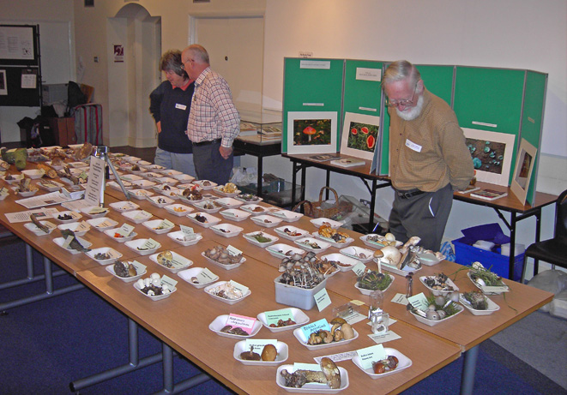

fig.1 Setting out the display at the Aylesbury Museum 6 October 2007 (JD)

IDENTIFICATION SESSIONS

You may have noticed that there is no identification session included in the programme this year. At our AGM in May we discussed the somewhat limited support for these in previous years, and thought that perhaps a new approach might prove more popular. So this year Derek and I are offering to share some individual time working on specimens you might like to bring along, giving you the opportunity to benefit from a wider range of literature: Derek’s library is extensive, and I also have a fair number of specialist books. As we both live in different parts of the county, one of us should be within reasonably easy reach of most members; so do feel free to give us a ring and we’ll try to arrange a suitable time. You know how it is: the interesting and puzzling fungi that you want help with always turn up in your local patch annoyingly just after a foray rather than conveniently just before one. Positive identification is of course not guaranteed, but we will do our best. There is also always the opportunity to bring things along to a foray for discussion before we move off: in this case could you give one of us a call beforehand so that we can plan to arrive early enough to accommodate this.

REPORT OF THE 2007/2008 SEASON
Derek Schafer

As in previous years, these reports give only a small selection of illustrative finds for each venue visited by the Group. We do now have available complete lists of the season's records for each site visit and these can be easily sent by e-mail to members or organisations that would like them.

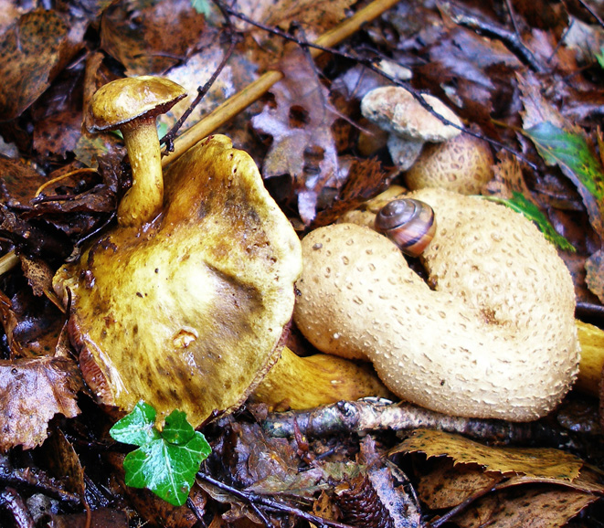
Despite another relatively poor year for the larger fleshy gilled fungi and boletes, 2007/8 produced a very diverse set of records, with many fungi recorded for the first time in the County. One of the reasons it is so easy to discover fungi new to Buckinghamshire is because there are so many sections of the fungal kingdom where specialist expertise is needed. Visits to Buckinghamshire sites by specialists such as Martyn Ainsworth, Kerry Robinson and Nick Legon cast a searchlight on the sites visited, producing records of microfungi, ascomycetes, rusts, smuts, mildews, corticioids and other fungi that may long have been present but have gone unrecognised. Penny and I can make our contribution but there really is an opportunity here for members of the Group to adopt an area of mycology and specialise in recording its fungi. fig.2 Pseudoboletus parasiticus on (itself) on Scleroderma citrinum
Someone with a good knowledge Marlow Common 29 Sep 2007 (PC)
of the plant kingdom would be in an excellent position to help identify many species that have specific host associations. So, please step forward! No need to be an expert at this stage, other mycologists will be happy to guide and assist!

Marlow Common 29 Sep 2007

Our first autumn foray was to this site, not visited by the Group before, and produced a list of 50 species. Pseudoboletus parasiticus (Parasitic Bolete), fig.2, a species that grows on Scleroderma citrinum, that Roger Wilding had found here in 2006, was found again. One of the specimens in the photograph seems to be taking its parasitism to extremes by growing on another fruit body of the same species! Other finds included Fistulina hepatica (Beefsteak Fungus, fig.3), Cystoderma amianthinum (Earthy Powdercap, Phillips p.138) and Phallus impudicus (Stinkhorn, fig.21 a to f). Also found was the very rare Galerina subclavata, with just 29 records for Britain and new to the County.

Pullingshill Wood 29 Sep 2007

Later the same day, the Group visited the adjacent Pullingshill Wood, adding a further 72 records including Aleuria aurantia (Orange Peel Fungus, Phillips p.367), Cortinarius torvus (Stocking Webcap, Phillips p.195), Geastrum rufescens (Phillips p.335), Hydnum repandum (Wood Hedgehog, BFG Newsletter 6 p.6), Inocybe assimilata (Phillips p.224), Inocybe flocculosa (Fleecy Fibrecap, fig.4) and Xylaria longipes (Dead Moll's Fingers, Phillips p.370).
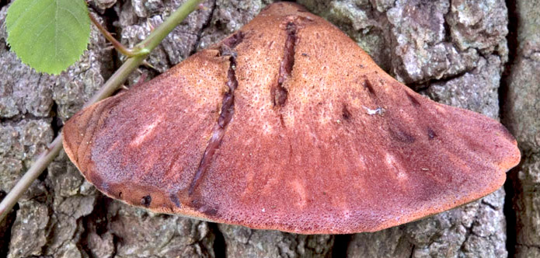

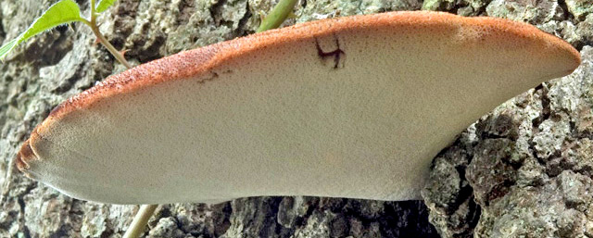

fig.3 Fistulina hepatica this specimen on an Oak tree at Harcourt Arboretum (DJS)

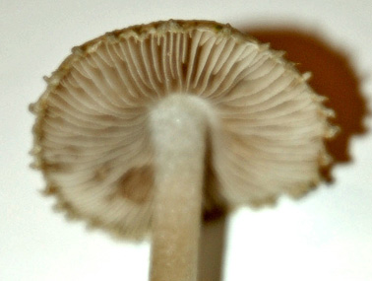
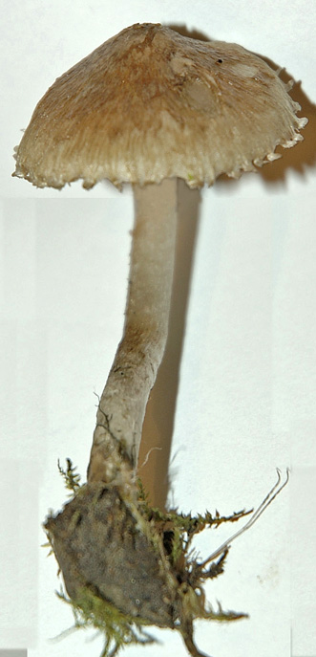
Danesborough 30 Sep 2007

This foray on the sandy soil of the greensand ridge bordering Bedfordshire produced a number of unusual finds. Lanzia echinophila, a new record for the County, was growing on its usual substrate - the spiny husks of Sweet Chestnut, but also on the cupules of Turkey Oak (fig.5). Oak cupules have been reported before as a substrate for this species, but not often. Interestingly, when acorns are the substrate, the spiny acorns of the Turkey Oak seem to be a more frequent host than those of native oaks. Other finds included Inocybe flocculosa (fig.4) again, Lasiosphaeria spermoides (Ellis& Ellis p.32),

fig.4 Inocybe flocculosa specimen from Whitchurch in 2005 (DJS)
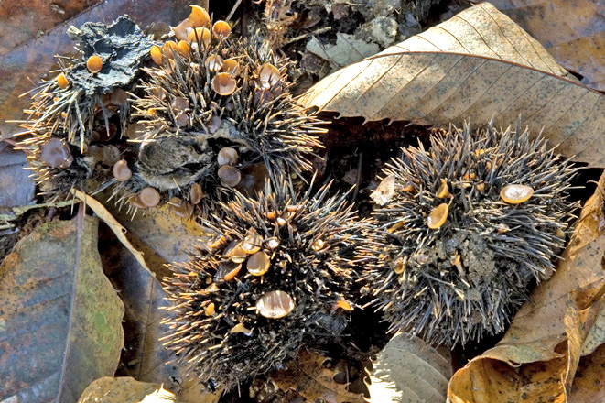

a

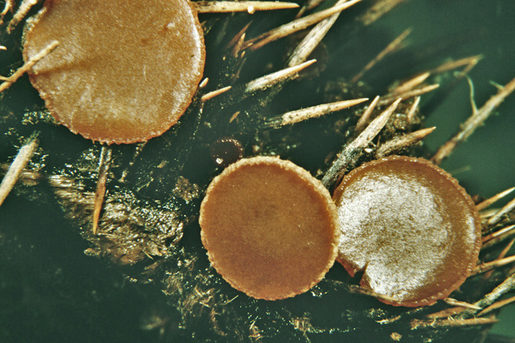
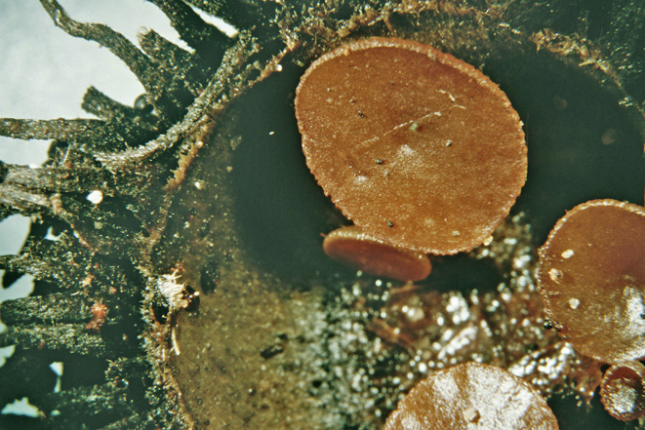

b c

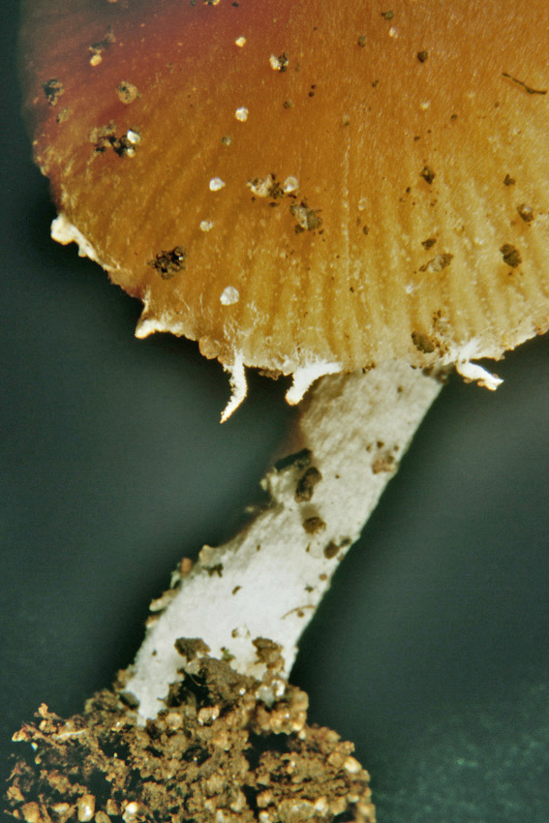
fig.5 Lanzia echinophila Danesborough 30 Sep 2007
(a)&(b) on Sweet Chestnut husks (c) on Turkey Oak cupule

Conocybe (=Pholiotina) velata (fig.6), Pleurotus cornucopiae (Branching Oyster, Phillips p.265), Pycnostysanus azaleae (Bud Blast on Rhododendron), Russula acetolens (rarely recorded in Britain so far, although some past records of R. lutea, now regarded as a nomen dubium, will have been this species, most probably having referred to R. risigallina), Russula amoenolens (confused with R. sororia in Britain until recently, so less often recorded, although Penny has found it at many Buckinghamshire sites), Tazetta catinus (fig.7)

fig.6 Conocybe velata
Danesborough 30 Sep 2007 (DJS)
and the dramatic looking Volvariella bombycina (Silky Rosegill, fig.8). An equally dramatic specimen of Ganoderma australe (Southern Bracket, fig.9) was making short work of a Beech tree.
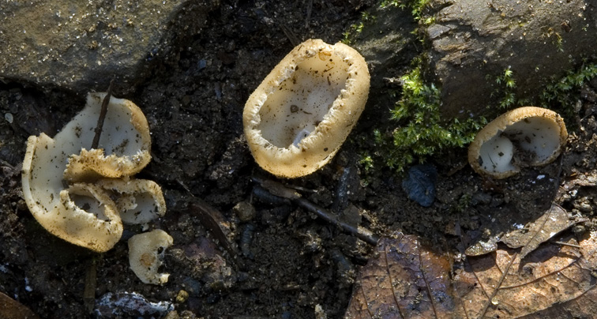

fig.7 Tazetta catinus Danesborough 30 Sep 2007 (DJS)
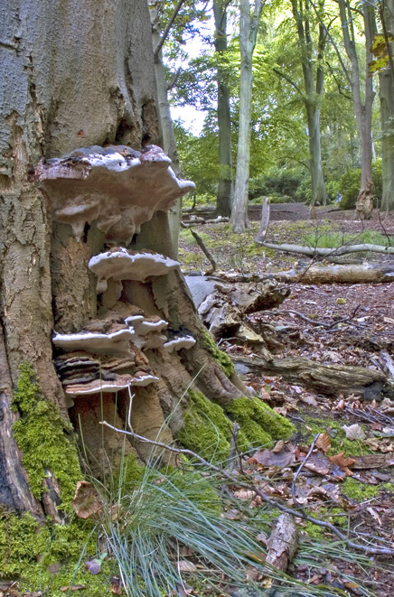

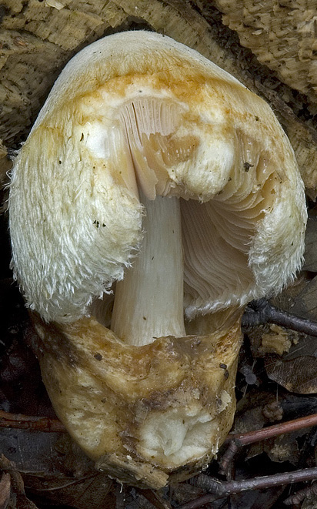

fig.8 Volvariella bombycina
Danesborough 30 Sep 2007 (DJS)

fig.9 Ganoderma australe
Danesborough 30 Sep 2007 (DJS)
Sheephouse Wood 5 Oct 2007

A small number of stalwart members turned up for this Friday foray aimed, among other things, at finding material for the Museum event the following day. A list of 35 species included the rare Conocybe fuscimarginata (new to the County), the tiny Mycena bulbosa on Rush stems, Bolbitius reticulatus (Netted Fieldcap, Phillips p.233), Simocybe sumptuosa (Phillips p.229) and Junghuhnia nitida (BFG Newsletter 8 p.20).

Mushroom Magic Exhibition, Bucks County Museum, Aylesbury 6 Oct 2007

Despite a relatively poor season, Group members brought in another outstanding display of freshly collected fungi (see fig.1). This is now part of a family event throughout the Museum and, among other things, children were set the task of completing a quiz relating to a number of different displays. This led to a steady stream of young visitors wanting to know the name of the red toadstool with white spots (one of Nick Jarvis's magnificent photographs providing the answer).

Pulpit Hill 7 Oct 2007

This foray was attended by several new members or visitors with cameras, so an attractive bunch of Mycena haematopus (Burgundydrop Bonnet) encountered at the start was much photographed (my effort is fig.10). Other finds included Clitocybe

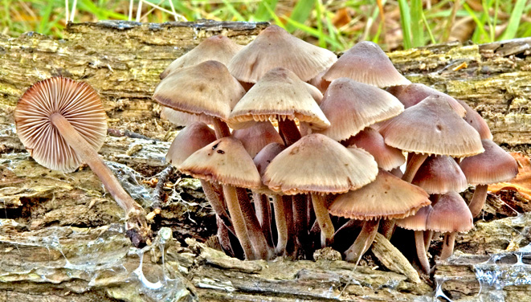

fig.10 Mycena haematopus Pulpit Hill 7 Oct 2007 (DJS)

houghtonii (Phillips p.93), Geastrum triplex (Collared Earthstar, Phillips p.335), Geastrum fimbriatum (Sessile Earthstar, BFG Newsletter 7 p.5), the rarely recorded Inocybe obscurobadia, Lepiota aspera (Freckled Dapperling, Phillips p.131), Marasmius wynnei (Pearly Parachute, Phillips p.117), Pluteus umbrosus (Velvet Shield, Phillips p.167), Psathyrella tephrophylla (a new County record) and Stropharia caerulea (Blue Roundhead, fig.11).

Burnham Beeches "Walk & Talk" 14 Oct 2007

Martyn Ainsworth tutored this outstanding day's event. The day started with a slide
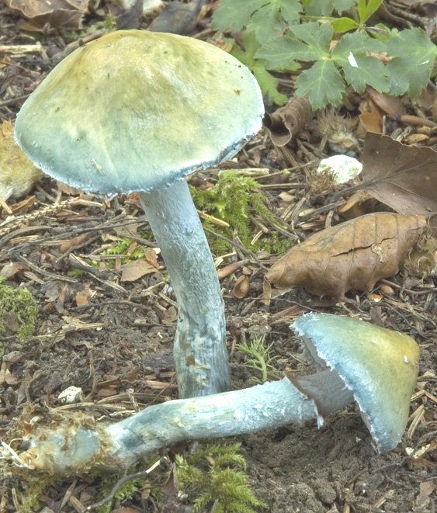
show illustrating many of the polypores we were to find during our walk later in the day, Martyn explaining the significance of many of them as indicator species in the conservation of fungi. This was followed by a guided walk through the Beeches to see the fungi at first hand. Finally, after lunch, Martyn used microscopes linked to the projector to demonstrate techniques used in identification of more difficult species. During the day, 81 species were recorded (not all of them polypores) including Agrocybe rivulosa (fig.12, see also comments and photo in BFG Newsletter 8 pp.19 & 21). Other finds included 5 slime
moulds, of which one, Arcyria
fig. 11 Stropharia caerulea Pulpit Hill 7 Oct 2007 (DJS)

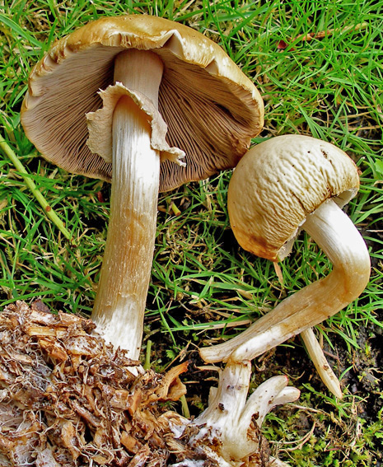
denudata (fig.38), is illustrated in Penny's article on p.30, Coprinopsis picacea (Magpie Inkcap, fig.16), Schizopora flavipora, Inocybe dulcamara (Phillips p.218, a new County record) as well as indicator species Ceriporiopsis gilvescens (BFG Newsletter 7 p.7) and Ganoderma pfeifferi (figs.13 to 15). The latter was found growing on the same tree where it had been found in 2005 (fig.13) but with the original fruit body removed and a new one starting to take its place (fig.14). Fig.15 shows a fruit body that had been growing on a tree trunk, which subsequently fell over. A later fruit body has emerged growing at right angles to the earlier one, which is now vertical and not horizontal.

fig.12 Agrocybe rivulosa Burnham Beeches 27 Jul 2007 (PC)

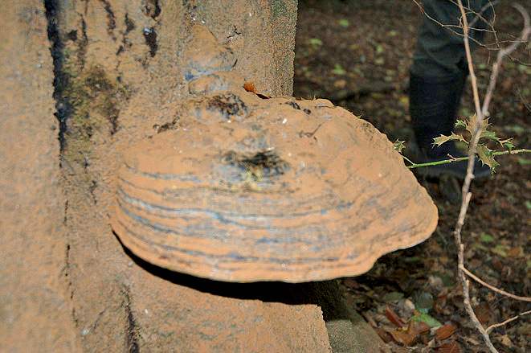

fig.13 Ganoderma pfeifferi
Burnham Beeches
Oct 2005 (DJS)

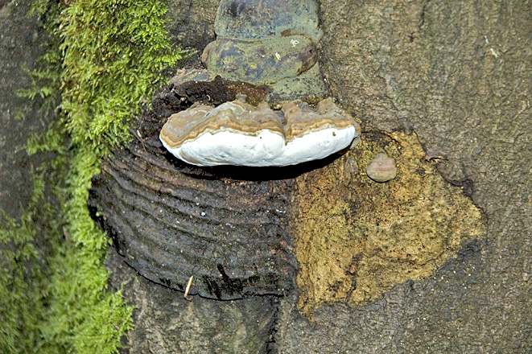

fig.14 Ganoderma pfeifferi
Burnham Beeches
14 Oct 2007
regrowing where old
fruit body removed (DJS)

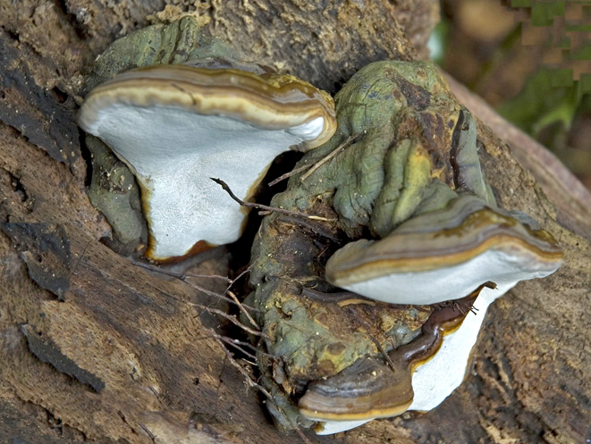

fig.15 Ganoderma pfeifferi
Burnham Beeches
14 Oct 2007
on fallen log
growing at
right angles to
earlier fruit
body (DJS)

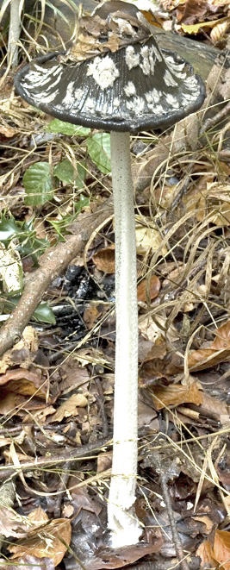
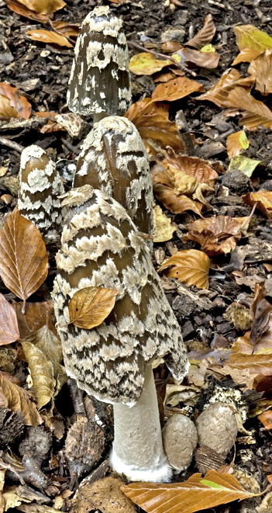

fig.16 Coprinopsis picacea Burnham Beeches
14 oct 2007 (DJS)
Homefield Wood 27 Oct 2007

This was another site not previously visited
by the Group and 78 species were recorded during the visit. The list included a variety of rare and unusual finds including Conocybe velata (fig.6), Conocybe arrhenii and Conocybe vexans, the latter new to the County and rarely recorded in the south of England. Other finds included Coprinopsis echinospora, Cortinarius crystallinus, 10 Mycena species including the beautiful, tiny Mycena adonis, Typhula phacorrhiza, Crepidotus lundellii, Micromphale brassicolens (called Cabbage Parachute because of its unpleasant smell of rotten cabbage, Phillips p.78) and Typhula phacorrhiza, growing from a tiny liver-shaped sclerotium.

Moor Wood 27 Oct 2007

This privately owned wood in the Frieth area had been visited by the Group in 2003 and 2005. The afternoon's visit produced a list of 62 species including Cortinarius delibutus (Yellow Webcap, BFG Newsletter 7 p.8), Pleurotus dryinus (Veiled Oyster), Stereum rameale, Stropharia squamosa (of which there is a wonderful 'Fungal Portrait' on page 75 of Field Mycology 9(3) of July 2008, under its new name of Leratiomyces squamosus) and Junghuhnia nitida (see BFG Newsletter 8 p.20).

Cliveden 28 Oct 2007

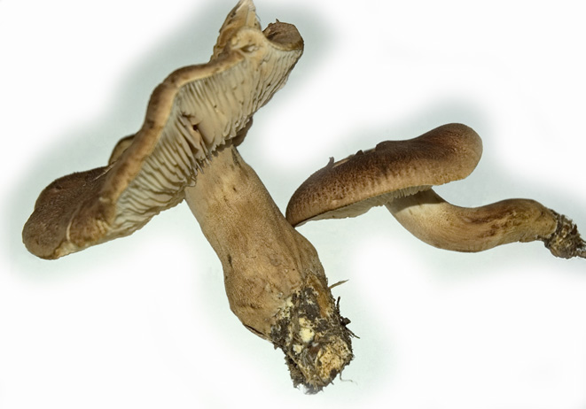
Our first Group visit to the grounds of this magnificent (if politically infamous) country house produced a list of 111 species. The species recorded provide a good guide to the sort of season we had in the autumn of 2007 - rather few mycorhhizal species, but no fewer than 17 Mycenas! Finds included Bolbitius lacteus (a new County record), Clavulinopsis helvola (Yellow
Club, BFG Newsletter 7 p.10), Cordiceps
militaris (Scarlet Caterpillarclub,
Phillips p.375), Crinipellis scabella
(Hairy Parachute), just 5 Hygrocybe
species, Inocybe curvipes, Psilocybe
cyanescens (Blueleg Brownie,
Phillips p.252 a new
County record), six
Russulas identified by Penny). fig.17 Tricholoma
including Russula insignis (a new County record), imbricatum
and Tricholoma imbricatum (Matt Knight, fig.17) Cliveden, 28
Oct 2007 (DJS)
Stowe Landscaped Gardens 4 Nov 2007

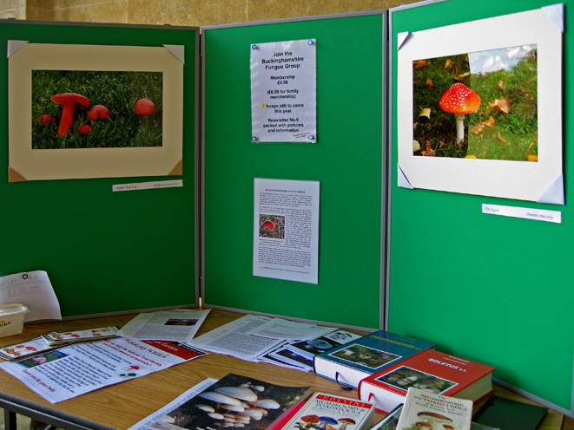
Sadly, we are not able to repeat this event in 2008 but in 2007 it provided an introduction to fungi to some 90 attendees, going out in groups of 15 accompanied by Group members and bringing finds back to a central display for identification and labelling. Despite an apparently poor showing of fungi at this time of year, the display was impressive (back page) and, with the help of guest mycologist Kerry Robinson (fig.18) we produced a record list of 132 species including many new to the County.

fig.18 Stowe Landscape Gardens 4 Nov 2007 with Penny Cullington and Kerry Robinson, on right (AH)

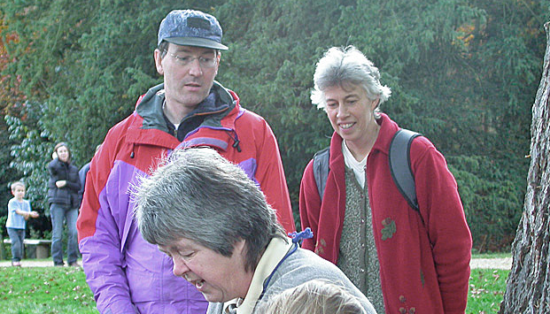

The Stowe list included new County records of Lachnum cerinum, Lepiota fuscovinacea (Phillips p.133), Patellaria atrata, Phyllactinia fraxini and Puccinia buxi. Other uncommon finds included Clitopilus hobsonii, Cercospora mercurialis, Erysiphe cynoglossi, Fusidium aeruginosum, Henningsomyces candidus, Menispora ciliata, and Sowerbyella radiculata (fig.19). The latter had been found in Buckinghamshire before but only twice in 1867 and 1878 respectively, so officially it has been extinct in the County for some time!
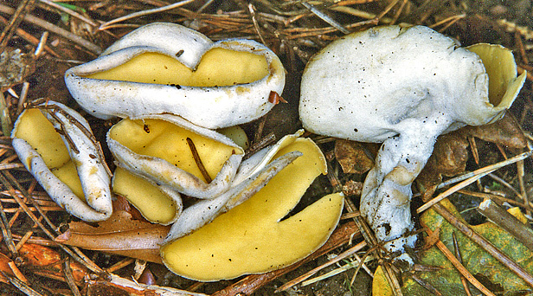

fig.19 Sowerbyella radiculata Collection from Scales Park 1993 (KR)

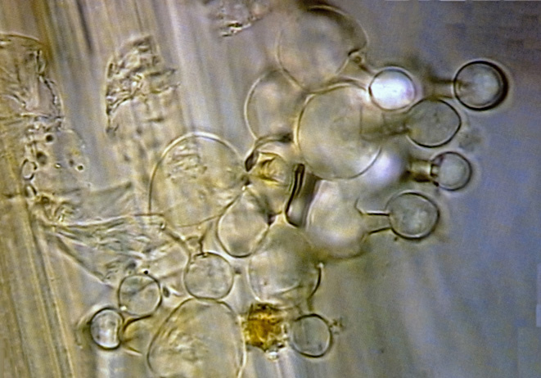
Waxcaps were a special target in connection with the National Trust's 'Waxcap Watch' - 9 species/varieties were found, including Hygrocybe pratensis (Meadow Waxcap, Phillips p.72), Hygrocybe psittacina (Parrot Waxcap, Phillips p.74) and Hygrocybe punicea (Crimson Waxcap, Phillips p.75). Larger fungi contributing to a fine display included Laetiporus sulphureus (Chicken of the Woods, see front cover), Phaeolus schweinitzii (Dyer's Mazegill, BFG Newsletter 7 p.3), Meripilus giganteus (Giant Polypore, Phillips p.301) and a large bunch of Armillaria mellea (Honey Fungus, Phillips p.100).

Penn Waxcap Foray Thursday
8 Nov 2007

We found eight waxcaps, including Hygrocybe ceracea (Butter Waxcap, Phillips p.77) along with other typical grassland species Mycena flavoalba (Ivory Bonnet, fig.20 Lecythiform (skittle-shaped) cystidia on the stem
Phillips p.86), Dermoloma of Conocybe subovalis Penn Vicarage 8 Nov 2008 (DJS)

cuneifolium (Crazed Cap), Clavulinopsis luteoalba (Apricot Club, Phillips p.343)
and Clavulinopsis helvola (Yellow Club, BFG Newsletter 7 p.10). Other records included Hebeloma velutipes and Conocybe subovalis. Species in the genus Conocybe often have lecythiform (skittle-shaped) cystidia on the gill edge and stem and fig.20 shows them on the stem of the species found on this foray. Also collected was Phallus impudicus (Stinkhorn, shown opening in fig.21 several days after it was collected).

fig.21 (a) to (f) Phallus impudicus from Penn Wood 8 Nov 2007 (a) on day of collection; (b) 2 days later (c) 2 days later plus 2 hours (d) 3 days later (e) 3 days later plus 1 hour (f) 3 days later plus 4 hours (DJS)
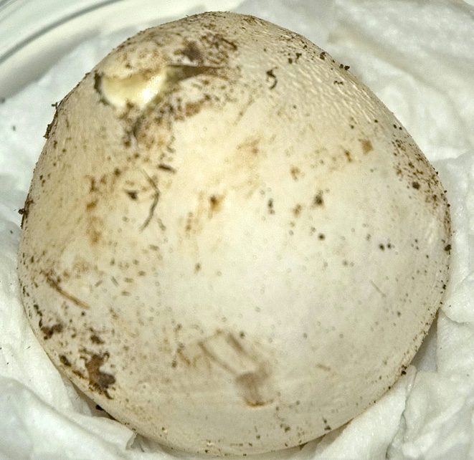
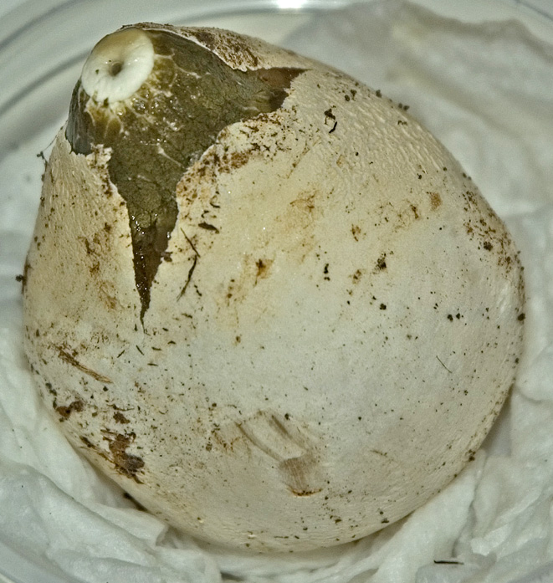
c
d

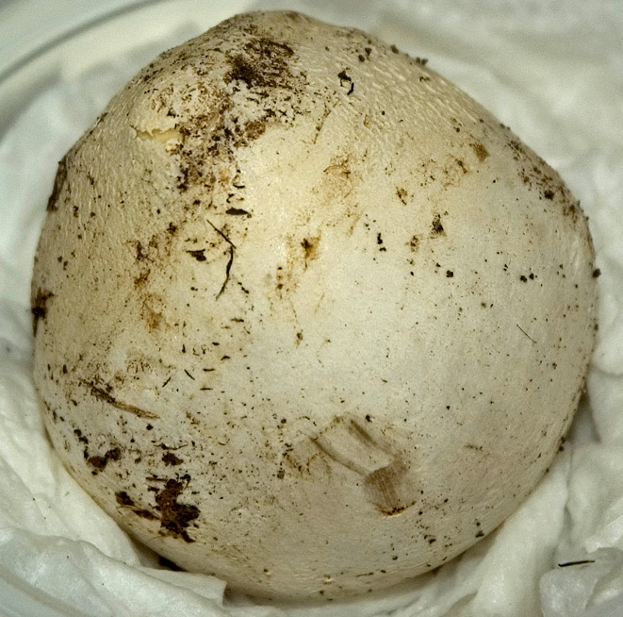

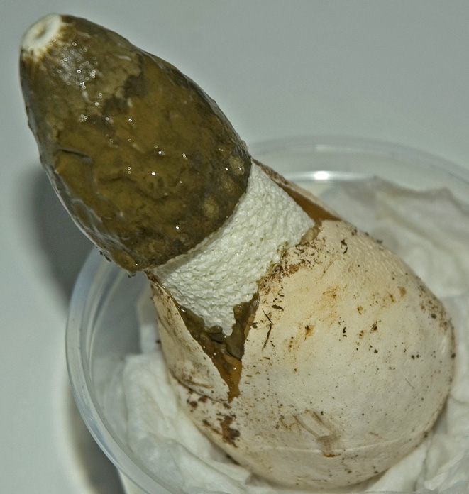

e

b
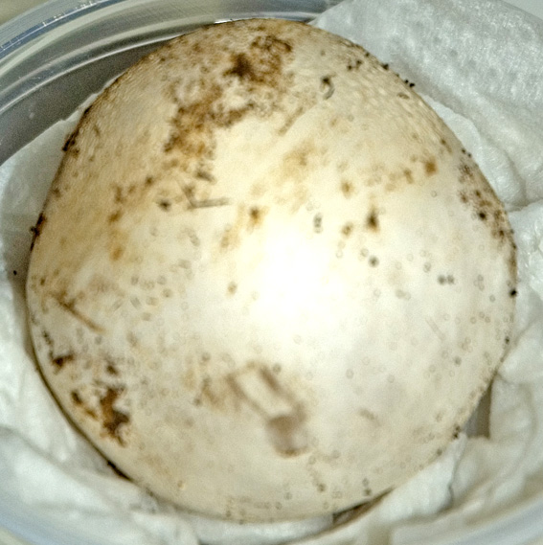

a

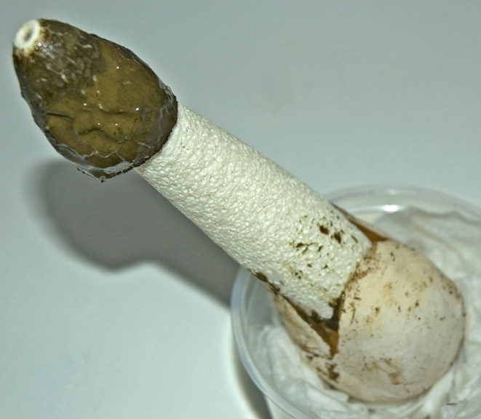

f

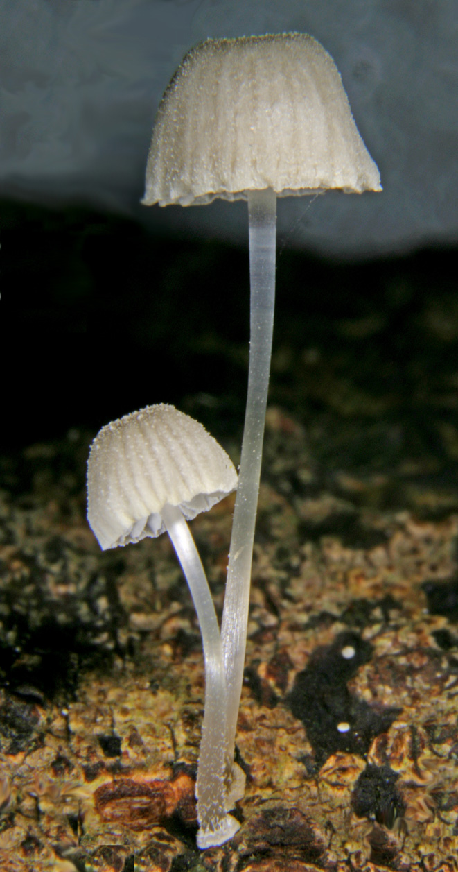
Finemere 18 Dec 2007

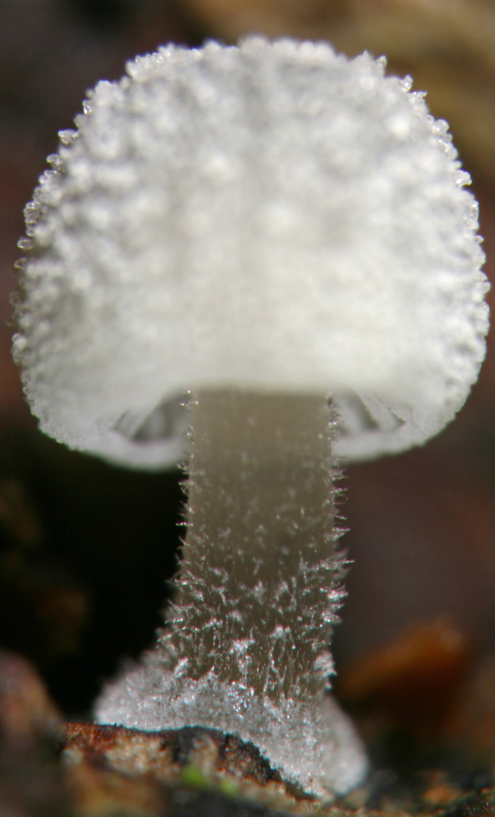
What was meant to be a leisurely stroll followed by a bowl of soup at Duck End House, turned into more of an ordeal for Jenny, who broke her foot getting
out of the car and struggled around the wood in pain as the foraying proceeded. Soup was served on instructions from her invalid chair back home, the list of 46 species meagre compensation, but including Tremella encephala growing on Stereum sanguinolentum (see BFG Newsletter 8 p.19), Crepidotus luteolus (Yellow Oysterling, Phillips p.269), Cudoniella acicularis (Oak Pin, Phillips p.370), Mycena adscendens (Frosty Bonnet, fig.22) and Phlebiopsis
gigantea fig.22 Mycena adscendens This collection from Rushbeds Wood 10 Dec 2007 (DJS)
the cap on the left is 1.4 mm diameter, the larger on the right about 5 mm
Carpenters Wood 3 Feb 2008

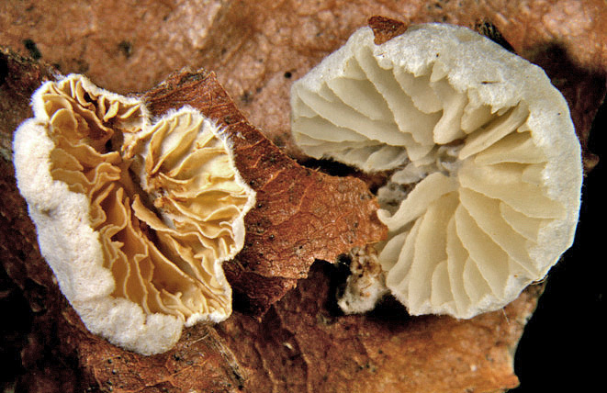
An early season visit to this wood in administrative Hertfordshire but Vice County 24 (Buckinghamshire) has become a tradition for a joint HFG/BFG foray. With Kerry Robinson joining the foray, records were added like a mycological Olympic Games. New County records (VC 24) were added for Flammulaster granulosa, Mollisia ligni, Rosellinia mammiformis and Hemitrichia clavata (this might not be new to the County since by no means all Myxomycete records are on the fungal database). Other finds in a list of 82 species included Eriopezia caesia (perhaps Penny could do an article on rhyming Latin names for the next issue?), Phlebiella filicina, Stypella subhyalina, Nemania confluens, Orbilia delicatula, Cudoniella clavus (Spring Pin) and Crepidotus epibryus (fig.23).

Rushbeds Wood 17 Feb 2008
fig.23 Crepidotus epibryus Carpenters Wood 3 Feb2008
This foray produced a list of 27 species
including Sarcoscypha austriaca (Scarlet Elfcup, BFG Newsletter 7 p.4), Diatrype bullata (BFG Newsletter 8 p.5), Hypocrea pulvinata (Ochre Cushion) on Piptoporus betulinus and Phellinus pomaceus (Cushion Bracket, fig.24), a regular on the Blackthorn at Rushbeds.
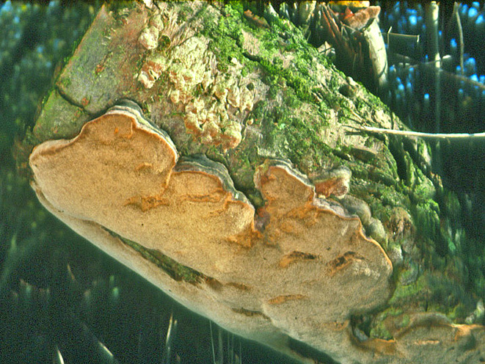

fig.24 Phellinus pomaceus on Blackthorn at Rushbeds Wood, this photo from Nov 1999 (DJS)
Hodgemoor Wood 16 Mar 2008

A total of 38 species were recorded including Geastrum triplex (Collared Earthstar, Phillips p.335), Geastrum fimbriatum (Sessile Earthstar, BFG Newsletter 7 p.5), new to the site, and Xylaria carpophila (Beechmast Candlesnuff, Phillips p.370).

Coombe Hill 20 Apr 2008

A list of 34 species included Hyaloscypha hyalina, 3 Myxomycetes including Trichia botrytis, Panaeolus fimicola (= P.ater, Turf Mottlegill, Phillips p.262) and Verpa conica (Thimble Morel, Phillips p.359).

Other Interesting Finds

My wood chip pile continues to evolve. This year, Agrocybe rivulosa (fig.12 and see BFG Newsletter 8 p.19-21) has failed to appear since June 2007. Instead, masses of Psathyrella conopilus (Conical Brittlestem, fig.25) appeared between August and October.
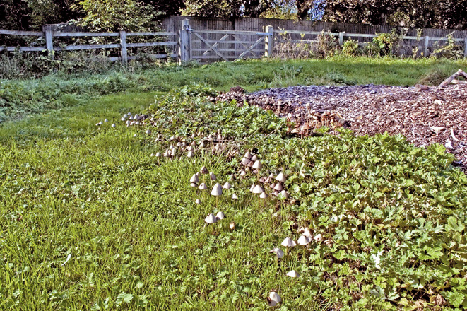

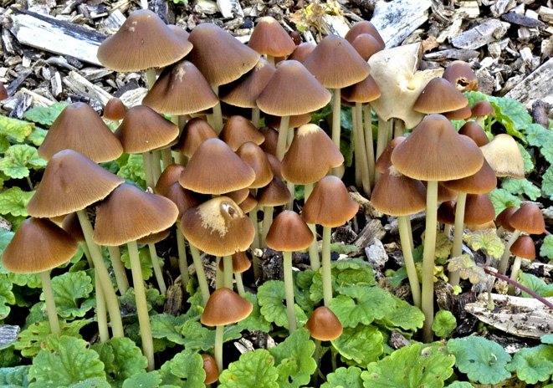

fig.25 Psathyrella conopilus Whitchurch 4 Oct 2007 (DJS)

Then from May 2008 large quantities of a Coprinopsis in Section Lanatuli (like C. lagopus) started to appear (fig. 26). On closer examination this turned out to be Coprinopsis pachyderma, which has pigmented, thick-walled veil cells on the cap and shorter spores than C. lagopus.

Originally described as a North American species, it has been reported from five locations in England, growing on wood chip. The first record from Chichester in 1998 (by Derek Reid) was the first European record. It is new to Buckinghamshire, although I had encountered isolated specimens back to 2003 in Whitchurch that were labelled as possible C. pachyderma.

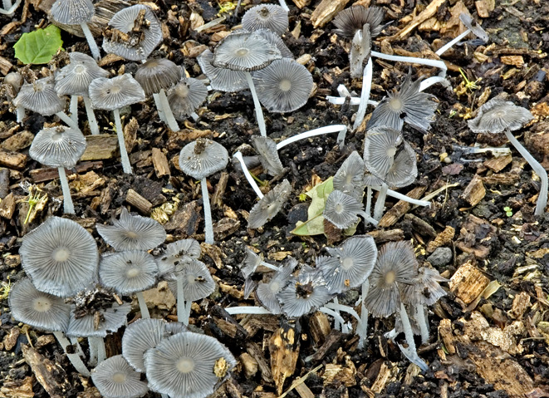

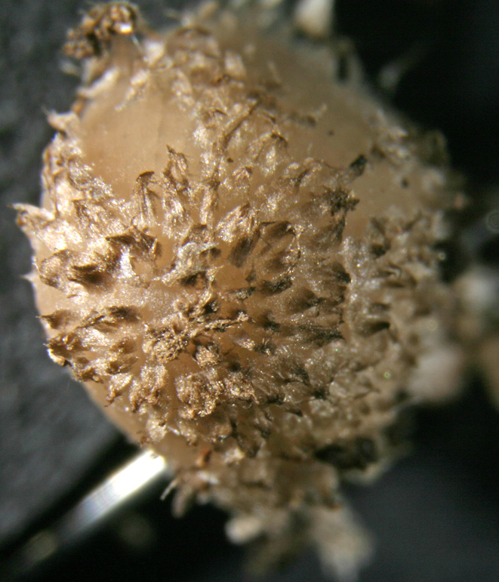

fig.26 Coprinopsis pachyderma Whitchurch
27 May 2008 (DJS)
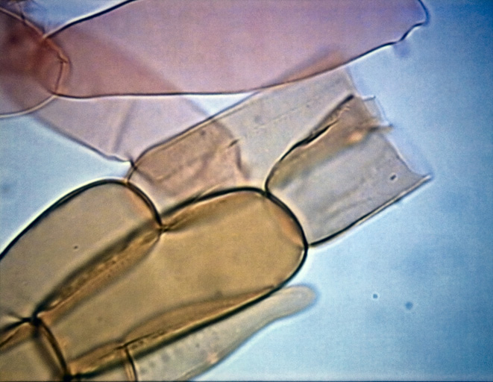

thick-walled pigmented veil cells
young fruit body showing pigmented veil on cap As you can discern from the foray reports, we have been increasingly tackling the LBJ's or 'Little Brown Jobs' of the fungal kingdom. Penny found the rare Conocybe percincta at Pulpit Hill in November 2007 (fig.27). It is new to the County. On the same visit, Galerina praticola and Coprinopsis pseudonivea were also found.
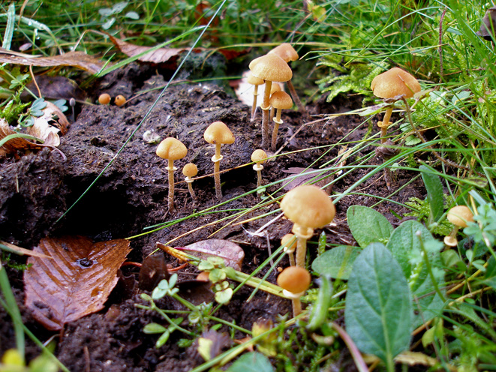

fig.27 Conocybe percincta on cow dung Pulpit Hill 2 Nov 2007 (PC)
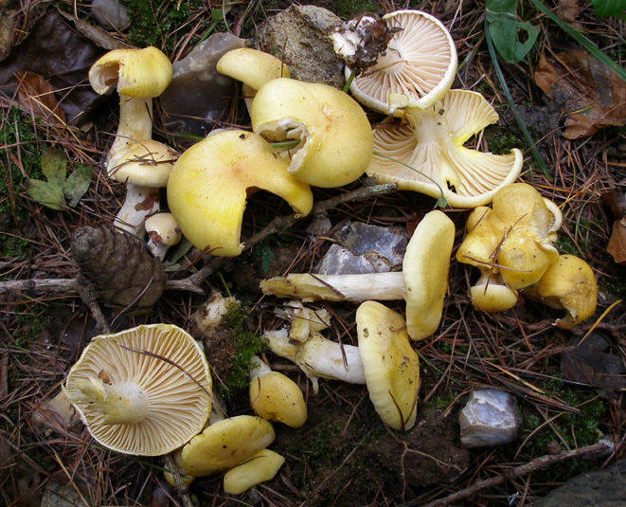

A rather fine species that grows with Larch and fruits late in the season is Hygrophorus lucorum (Larch Woodwax, fig.28) found by Penny this year at Penn Wood and Watlington Hill.

fig.28 Hygrophorus lucorum Watlington Hill 24 Oct 2007 (PC)
Another beautiful picture that I wanted to share with you is one that Penny took of Oudemansiella mucida (Porcelain Fungus, fig.29) at Hodgemoor in October.
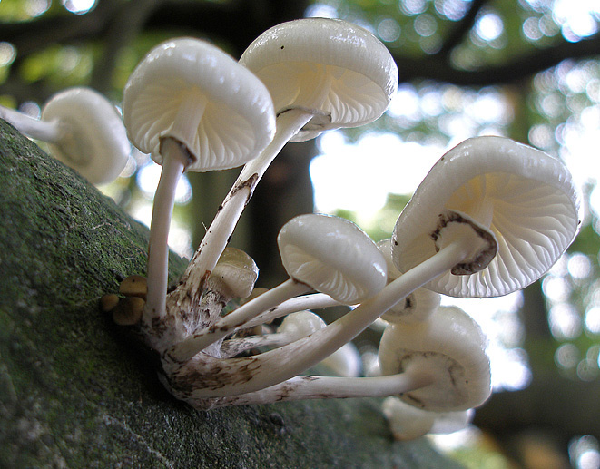

fig.29 Oudemansiella mucida Hodgemoor Woods 10 Oct 2007 (PC)

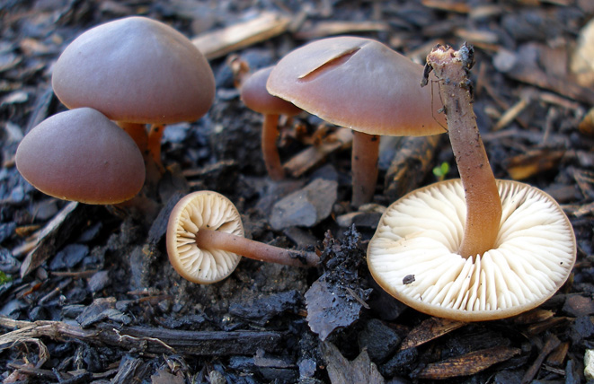
Back at home in November, Penny found some fine material of Macrocystidia cucumis (called Cucumber Cap because of its smell; fig.30 shows the fruit bodies growing in wood chip and also shows a microscopic view of the cystidia that give the fungus its latin name).

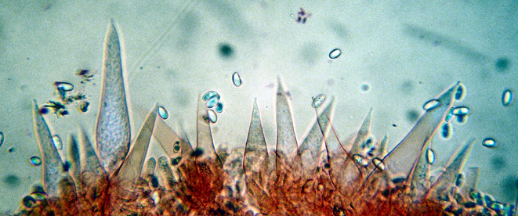

fig.30 Macrocystidia cucumis
Willow Lane Amersham
23 Nov 2007 (PC)

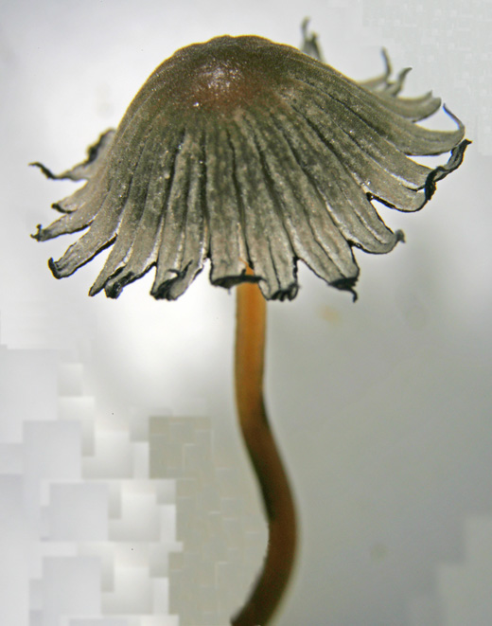
Finally, I couldn't resist including the Coprinellus stellatus (fig.31) that popped up on some Whitchurch horse manure in July demonstrating why it had been given that latin name. Other species have caps that split in a similar way but C. stellatus does it rather well. As it happens, the epithet 'stellatus' has been dropped by some in favour of 'brevisetulosus', but I think it would be a pity to lose it.
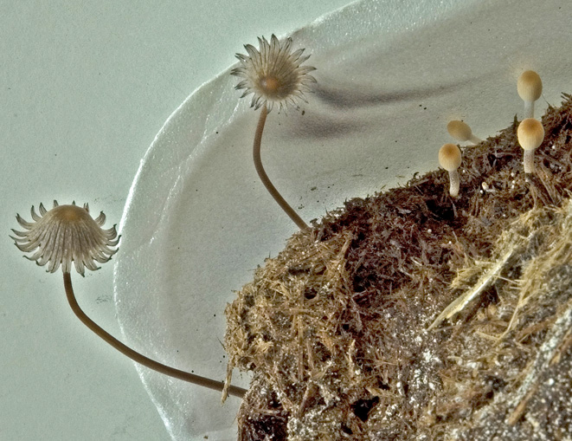

fig.31 Coprinellus stellatus
on horse dung Whitchurch
22 Jul 2008. The cap is
around 12 mm across(DJS)

ANYONE FOR A BIT OF SLIME?

No-one with an interest in fungi needs reminding of the baffling diversity of this kingdom of natural history: the more one discovers about it the more amazed one becomes. A few years back, after attending a BMS weekend workshop with Bruce Ing, I got bitten by a very individual group: the mysterious and often very beautiful Myxomycetes, commonly known as Slime Moulds. Certainly their English name does them no favours, however, and in fact probably puts many people off; this is a shame and partly why I’d like to share with you if I can a little about how they work and how to enjoy them, even if you don’t want to get into identifying them.

Firstly, what is a slime mould? Well, you might recall - if you’ll admit to being old enough! – the radio programme “Twenty Questions” in which the initial question asked by the panellists in their quest to discover the identity of an unknown object was “Animal, vegetable or mineral?” Not so easy in the case of myxos, as they are often called, because they just don’t sit comfortably within any kingdom - not even fungi - although they are studied and recorded by mycologists, who often affectionately refer to them as “honorary” fungi. When the first species was officially named and described back in the 1700s it was thought to fit somewhere near the puffball family (Lycoperdon) being similarly shaped and full of spores when mature,
albeit less than 2 cms across and bright orange. You may recognise from this the very common Lycogala (more on this below). However, during the 1800s it was realised that slime moulds were in fact distinct from fungi because they lack mycelium (the rootlike system present in fungi) but have plasmodium (the soft mobile slimy bit) as an important stage of their development. The name Myxo (= slime) mycete (= fungus) has remained, however, although at one stage it was even thought they could be part of the animal kingdom - the plasmodium actually “moves” across its substrate whilst taking up nutrients before settling down to mature into something much more reminiscent of the fungal kingdom. Now happily residing in kingdom Protozoa, these strange and fascinating organisms are still far from being fully understood.

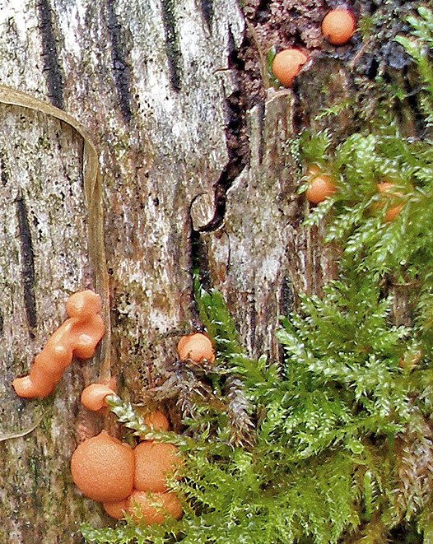
Lycogala terrestre (fig.32, left) with its conspicuous peachy orange blobs is probably the best known and most frequently recorded myxo. Its earlier plasmodial stage of reddish jelly-like slimy patches must of course be just as common, but may often go unnoticed in the field. The mature buff-coloured fruitbodies (fig.33, below) are inconspicuous, dry and crumbly, not the least bit slimy, and can also be easily overlooked. This species occurs at any time of year on damp rotting wood.

figs.32 & 33 Lycogala terrestre
with ripening sporangia left,
mature fruitbodies below (PC)
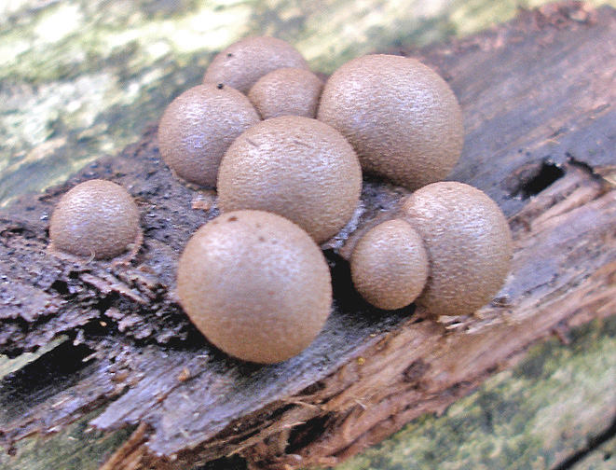

An entirely different but almost equally common species is Fuligo septica var. flava (figs.34 and 35 opposite). The septica part of the name always puts me in mind of a pile of puss on a log or leaf litter, and the flava part describes the colour which is an intense and conspicuous yellow with a hint of green. The plasmodium stage is not unlike
a dollop of scrambled egg (in my photo clearly being appreciated by the woodlouse!), followed by the drier and rather wrinkled mature stage.
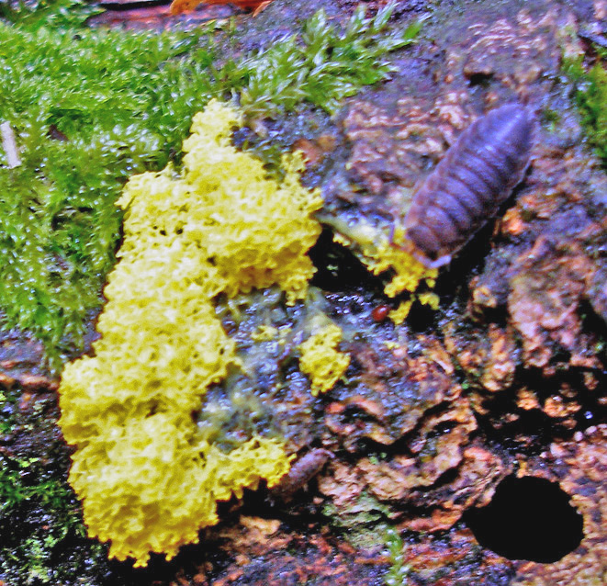
Unlike most fungi, myxos are not fussy about season, so can provide a source of interest throughout the year. After a rainy spell, whether warm or cold, it is worth glancing at the woodland floor, particularly on fallen rotting wood, even turning logs over, because that is where many species like to lurk. Another advantage of myxos over fungi is that if you are careful, the easily spotted plasmodium stage can be collected together with some of the surrounding substrate, then taken home and “incubated” so that one can watch the quite fascinating transition which takes place often within a matter of hours as it
figs.34 & 35 stages of Fuligo septica var. flava develops. Most plasmodium is white
plasmodium, above, mature stage, below (PC)
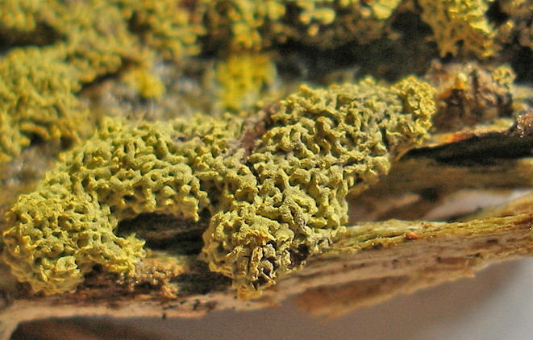

or cream and it is not possible to identify a species from this stage (any more than it is from fungal mycelium); a few have distinctively coloured plasmodium - bright yellows, reds, oranges - which can give an indication as to identity, but in almost all cases it is necessary to wait till maturity for this, when the variety of shapes, sizes and colours which emerge out of a shapeless blob of gunge is just mind-blowing. They can be tiny and are really best appreciated with a x10 lens or even better with a disecting or stereo microscope, when the detail of the sporangia – as the mature fruitbodies are called – can be admired: in fact a different world opens up before your eyes!
One early June day I gingerly collected two specimens of plasmodium, one white growing on pine, one yellow on beech. I kept them outside in a shady spot in a clear plastic container with the lid loosely attached to retain natural moisture but also to allow some air circulation and to keep slugs and snails at bay, having previously learnt the hard way that overnight specimens can disappear with only the telltale trail of the predator left behind to show for it! Next morning I was delighted to see both specimens had continued to develop, and within three days each had evolved into totally different shapes. As I had hoped, the yellow one turned out to be one of the pipe-cleaner-like genus of Stemonitis.This is a genus of some ten British species, easily distinguished by the shape of their mature spore mass (sporangia) which form closely-packed clusters like a stand of mini-trees (or pipe-cleaners). The commonest is S. fusca which has the white mycelium typical of the genus, and when mature the sporangia are dark fuscous brown with stems – known as stalks in myxos - forming half the overall height which can be up to 2cm; S. flavogenita, however, has yellow plasmodium and develops reddish brown sporangia with stalks only a third of the overall height which in this case was 8mm., much smaller than S. fusca. Below (fig.36 a to e) is the sequence of photos taken over three days and showing the amazing metamorphosis which takes place in these extra-ordinary organisms from plasmodium (the slime stage) to sporangium (the mature dry stage). The final shot, fig.36 f, is of a dry mount using a microscope and showing the delicate framework (capillitium) with central spine (columella) which supports the spore mass before it is dispersed by air currents. To reveal this structure I took a single specimen and blew gently on it to remove the now mature spores; notice here the corkscrew-like twist seen at the top of the columella, a diagnostic characteristic of this particular species. Note the Orbilia delicatula = xanthostigma (little orange discs less than 1 mm. across) just visible in shots b, c and e which give an idea of scale.

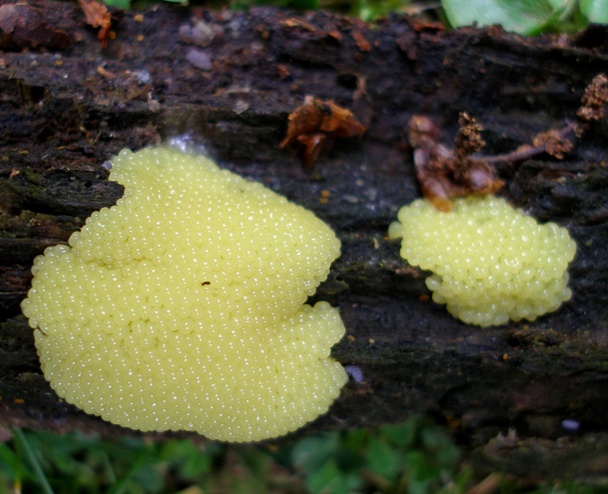

a

→

fig.36 a to f showing the development from plasmodium through to maturity of Stemonitis flavogenita (PC)
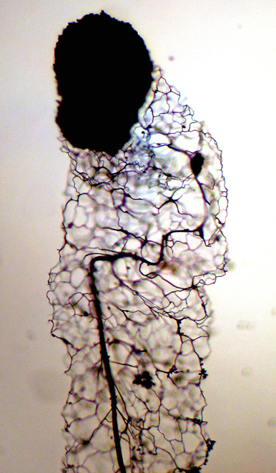
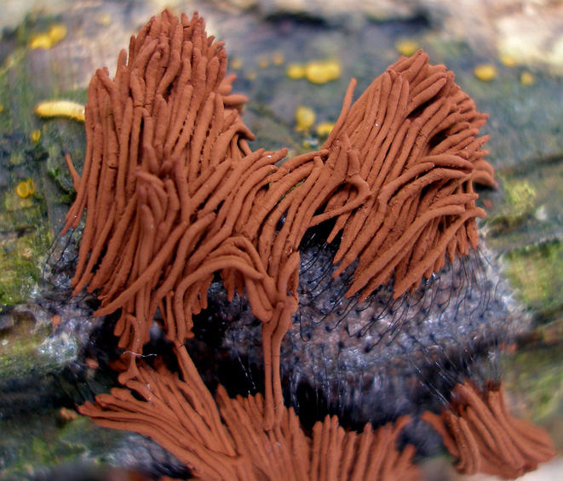
f

e

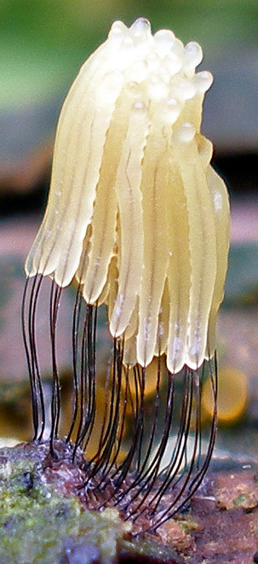
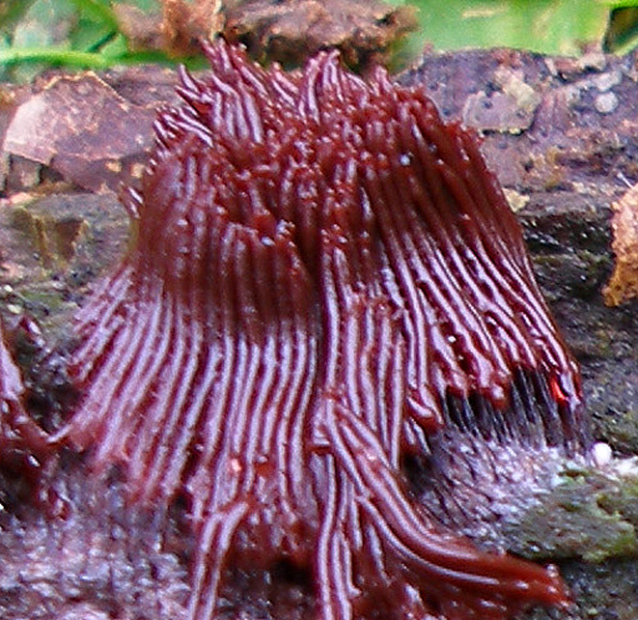
↑
d

b

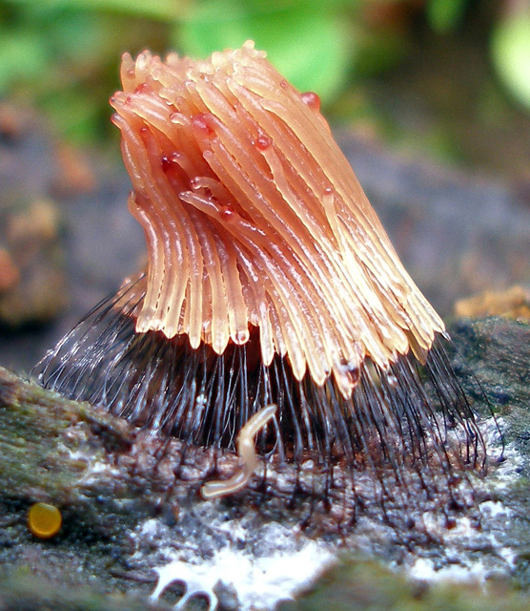

↑
c

→

The white plasmodium I’d collected could have been one of any number of things, and I was only sure of its identity when from the developing long thin pale tubes emerged the beautiful and delicate mini-loofahs typical of the genus Arcyria. Of the twelve British species in this genus A. obvelata (shown in fig.37 a to f below) is distinctive with its pale buff-yellow sporangia, about 12mm. long, and flimsy drooping habit. Here the final shot (f) shows a microscopic view of the loofah-like structure (the capillitium) formed of spiny ridged golden threads resembling a complicated model railway track.

fig.37 a to f showing the development from plasmodium to maturity of Arcyria obvelata (PC)
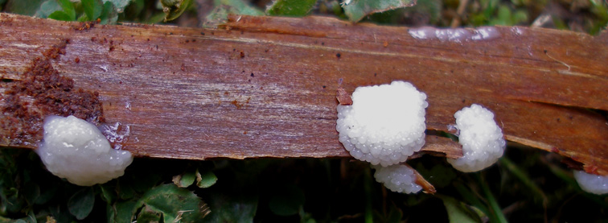

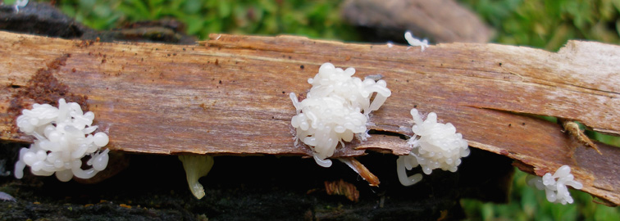
a ↓

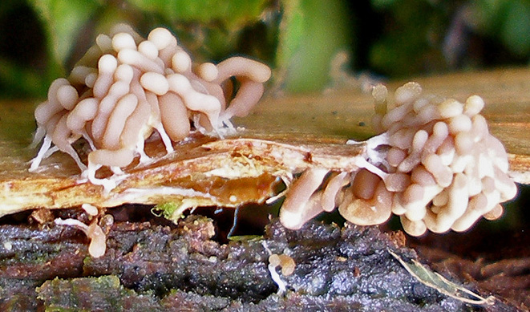
b ↓

→

c

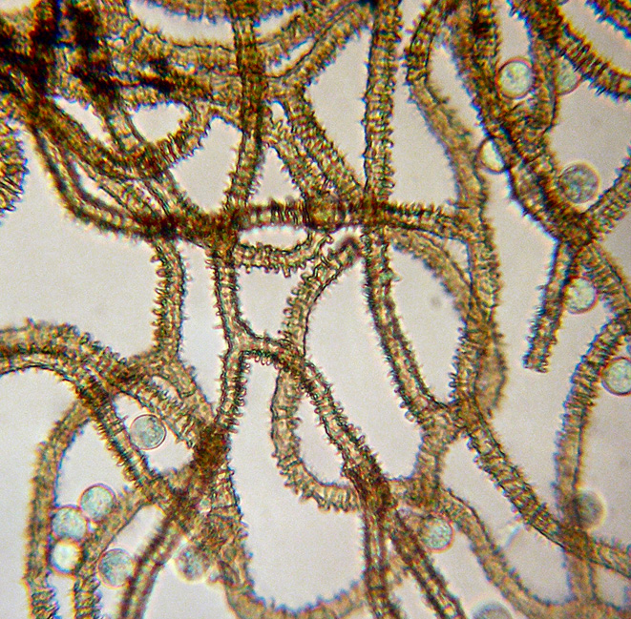

f

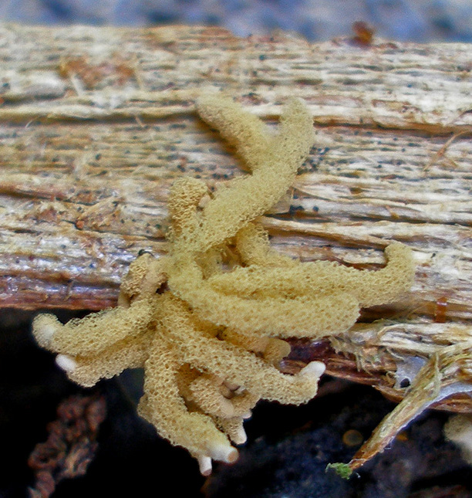
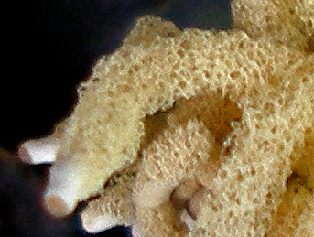
e

d

Below (fig.38 a to e) is another common and distinctively coloured species of Arcyria. Its plasmodial stage, not shown here, is white, but the bright cinnamon sporangia of A. denudata make it particularly notable, bringing to mind maybe a feather duster rather than a loofah? The first view was taken in situ from above as I found it, and the next three are side views taken at home over the following few hours; the train tracks (strands of capillitium) shown in the final microscopic shot (e) really are this wonderful colour – no stains or editing used here, honest! You can also see a few spores floating about, being the typical round shape found in virtually all myxos.

fig.38 a to e showing the developmental stages of Arcyria denudata (PC)

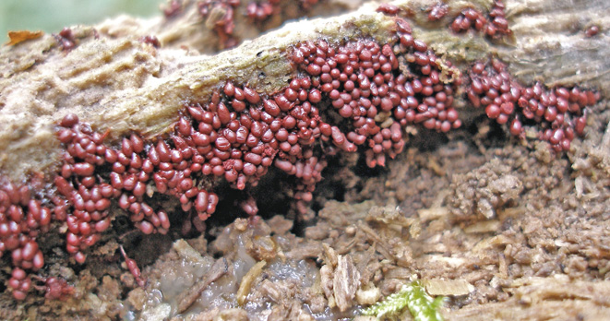

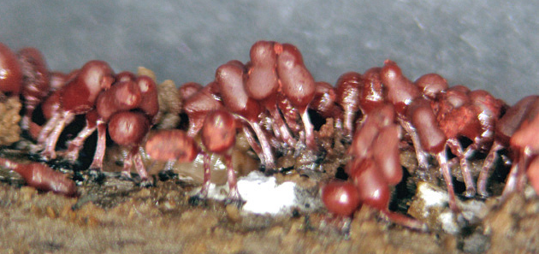
a b

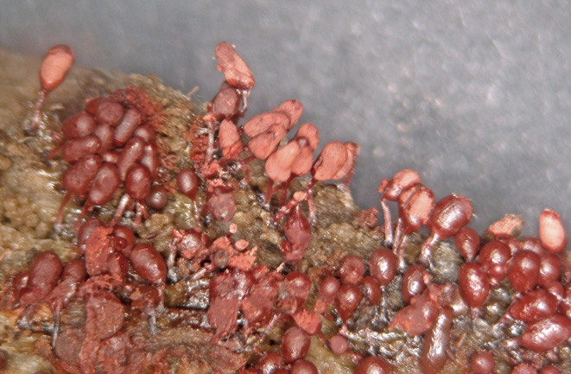
c
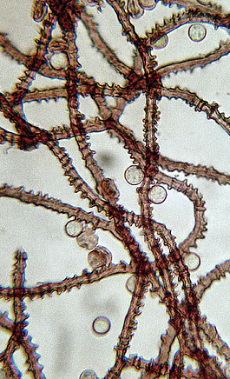

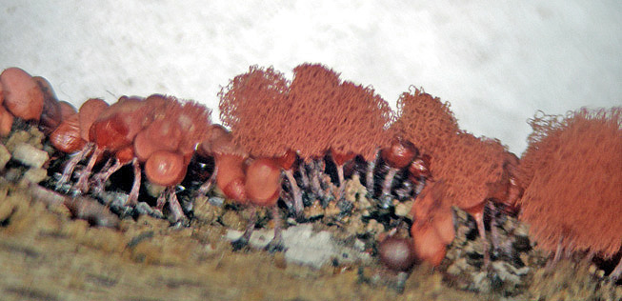

e

d
I’m hoping that, if you’ve not been tempted to look for or at Myxomycetes before, I’ve begun to stir your interest. With regard to reference books, sadly the situation is far from satisfactory, with no handy pocket guides in existence and virtually no myxos illustrated in any of the general fungi guides. For those with a serious interest Bruce Ing’s book, The Myxomycetes of Britain and Ireland, is a must. Brought out nearly ten years ago, it has keys and detailed descriptions of all species together with line drawings of microscopic features, but very regrettably no illustrations, and I would have to admit that the terminology is not for the faint-hearted! I have found, however, that using it in conjunction with another little book – Myxomycetes of Japan by Hagiwara and Yamamoto – has worked well. The Japanese book has excellent photos of well over a hundred species (most but not all of which occur in Britain) but the script is entirely useless unless you read Japanese - only the Latin names under the photos are in English, if you see what I mean! I long for a book which shows all the stages of a species as I have attempted to do here: it would put a completely new complexion on identification, and I’m sure would encourage many more field mycologists to widen their horizons in this direction.

If you want to try experimenting with specimens of plasmodium here are a few tips:

- At all costs avoid touching the surface – it will just collapse and will never develop further.

- Aim to take enough of the surrounding substrate to support the untouched plasmodium, using a knife if necessary.

- Transport it flat in a suitable container, preferably with a lid, again taking care that nothing comes in contact with the plasmodium.

- Once home transfer it to a loosely covered transparent container, and keep in a cool place – you are aiming to replicate the conditions in which you found it growing.

- If immature it may well “move” i.e. spread further over the substrate, even partly onto the container; but when ready it will begin drying off and rapidly changing colour and shape – often in a matter of just a few hours.

If you’re lucky this transformation will happen at a time of day when you can keep popping back to watch it. It’s really annoying if it all happens overnight: yes, you can marvel at the final sporangia in the morning, but it’s a pity to miss all the intermediate stages. When your specimen is clearly showing signs of change it’s a good idea to uncover it and move it to a warmer spot to encourage the drying off process. Myxos when fully developed and mature have a big advantage over fungi in that they will keep their form and colour indefinitely, whereas fungi just become shrivelled and unrecognisable. If you want, you can then take or post it to someone else to identify for you, although specimens are very fragile in this state. Photos are always useful; indeed, some species can be (fairly) safely identified this way, and also you can then refer back to them for comparison with other finds. It’s also well worth making a note of the plasmodium colour if it’s available. To show you why, I conclude with a photo of the very distinctive plasmodium of the fairly common Tubifera ferruginosa (fig.39 on the next page), although this particular species when mature is something of a let down in comparison. So if you notice blobs of brightly coloured paint on fallen damp logs in the woods, go and take a closer look: it might be a Myxomycete!
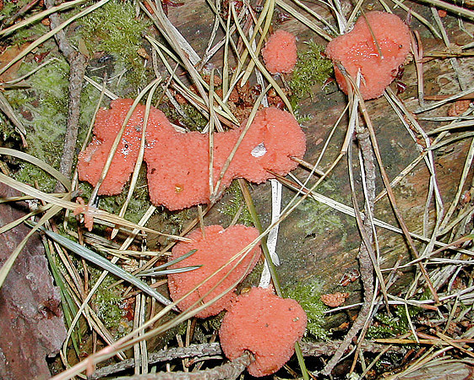

fig.39 Plasmodium of Tubifera ferruginosa (PC)

TWO RUSSULAS NEW TO THE COUNTY

I’ve already touched on the unusually dry September last season, and how despite the consequent dearth of fungi interesting things still seemed to turn up. My local patch was no exception, and two finds gave me particular satisfaction.

The first was Russula romellii (fig.40 with insert opposite) which I’ve long been on the look-out for in the Chilterns as it is known to associate with Beech but had thus far eluded me. Having just returned from the BMS Autumn Foray held in Derbyshire where this species is not uncommon and where I was able to become acquainted with its “jizz” (really a birding term but equally applicable to fungi, I think, meaning the characteristic features which distinguish any species from others which resemble it and which are not always easy to put into words but are learnt by actual sight and experience of the species in question), I was delighted to come across a young specimen in Common Wood a week later. This is a large fleshy species with a solid club-shaped white stipe and a smooth shiny cap beautifully rounded when young, although both cap and gill colour can be confusing (well, it wouldn’t be a Russula if it was too straightforward!). Cap colour can be red, purple, brown, olive, green, any combination of those, and often with cream patches especially in the centre; also as in R. curtipes – about which I wrote last year – the pale cream gills of the immature fruitbody (see fig.40 insert) develop a distinctly orange tinge and produce a deceptively dark spore print, one of the darkest in the genus.
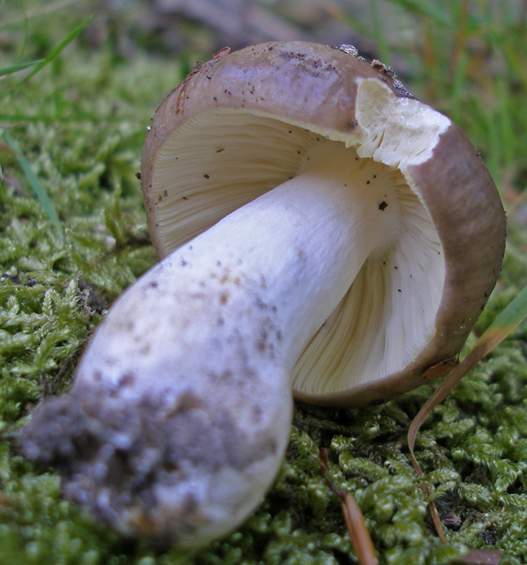
Two days later whilst dog-walking in the adjacent Penn Wood we stumbled across a real rarity which also grows under Beech. It had a small rose-pink cap with a darker centre and patches of cream around the rim and the stipe was white, ie so far looking superficially not unlike R. nobilis (= mairei) the Beechwood Sickener – could this be why it is not often recorded? Once we’d picked it the differences became apparent: all aspects of it were very fragile like R betularum, the cap peeled well over
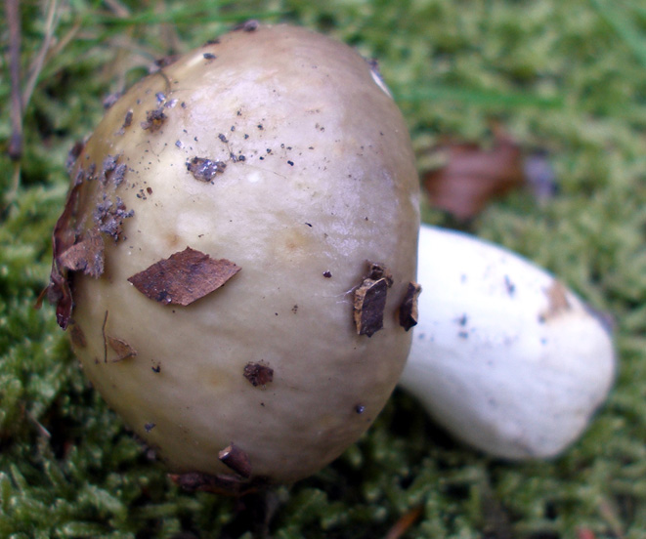

halfway and the flesh beneath was white and not pink as in R. nobilis; this together with the fact that the gill colour was not white but cream (see fig.41 on the next page) and the taste not hot but mild told us straight away in the field that we had something unusual and not connected with either R. nobilis or other members of the similar emetica group
fig.40 + insert Russula romellii Common Wood 15 Sep 2007 (PC) of Russulas.

Things were not in my favour when we got home because we promptly had a power cut all evening which prevented amongst other things any microscopy, and in the mean time the maggots were hard at work destroying the evidence as fast as they could munch, added to which I was out at work the next day – very frustrating! I did, however, discover one vital piece of information: it dropped a good thick spore deposit overnight which confirmed my suspicions that the spore print was mid-cream and not white.

Later that day I worked through keys and eliminated several possibilities such as R. melzeri (cap not grainy enough and spore print too pale), R. persicina (dermatocystidia were septate and the cuticle peeled too readily), R. luteotacta (no bright yellow staining where damaged, spore print too dark and again the cuticle peeled too readily), R. renidens (wrong tree association and no hot taste) and eventually stumbled across R. puellula and here at last everything fitted into place.

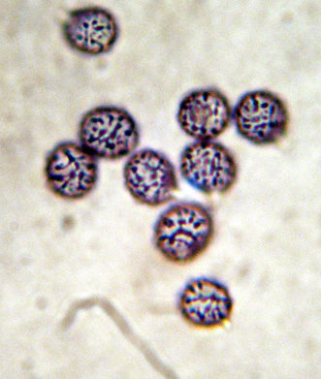
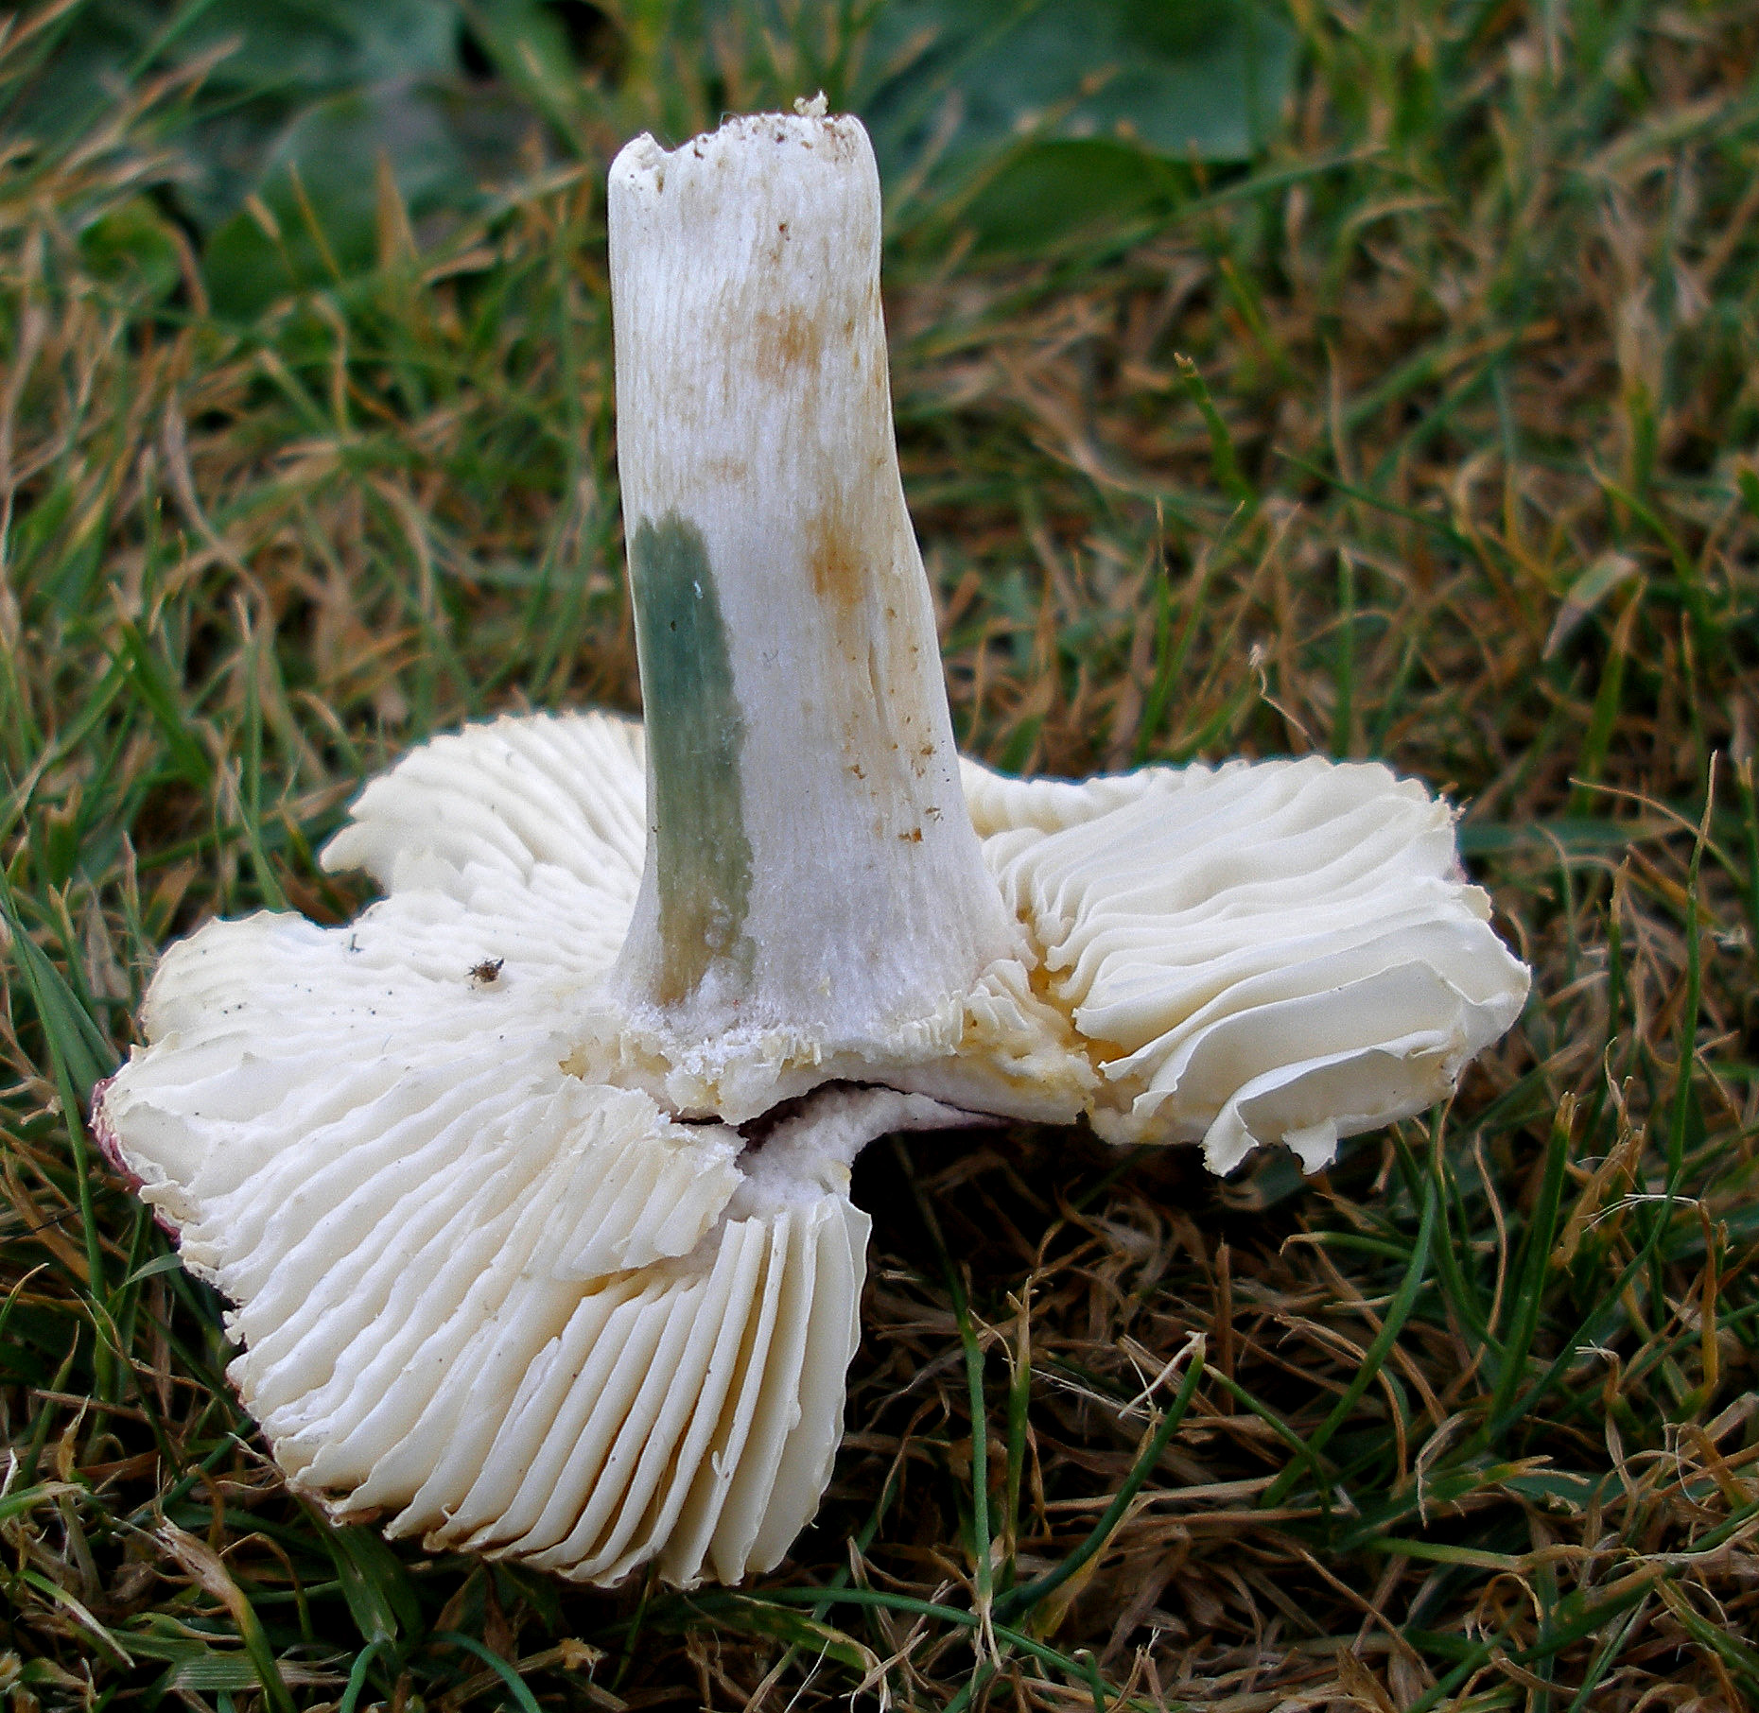
Russula puellula, (fig.41 below) I discovered, has a smallish fleshy but fragile cap, bright pinkish-red, shiny and slightly sulcate (with little furrows) at the margin, peeling ¾s or more; gills are pale cream and not crowded but fragile; stipe is white, short and also fragile; taste is mild, Guaiac on the stem is positive and also an Fe crystal gives a pale rust colour (both reactions are visible on the stipe in photo insert, top left); spores have warts with many connecting lines and crests (see photo insert, top right), spore print is cream; cystidia in the cap cuticle are long and thin with many septa, not very dark in
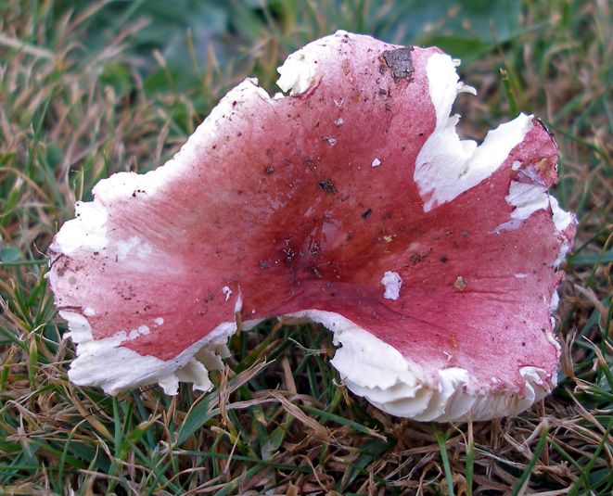

Sulphovanillin (see photo insert at bottom of page) hyphae are not fuchsinophile; habitat is with Beech. This is a rare species with only eight records to date on the FRDBI, and one I was thrilled to find in Bucks and have a chance to work on.
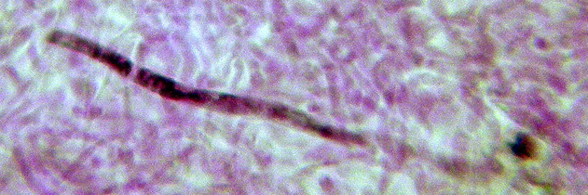

fig.41 Russula puellula Penn Wood
17 Sep 2007 (PC)

HERICIUM SPECIES IN BURNHAM BEECHES

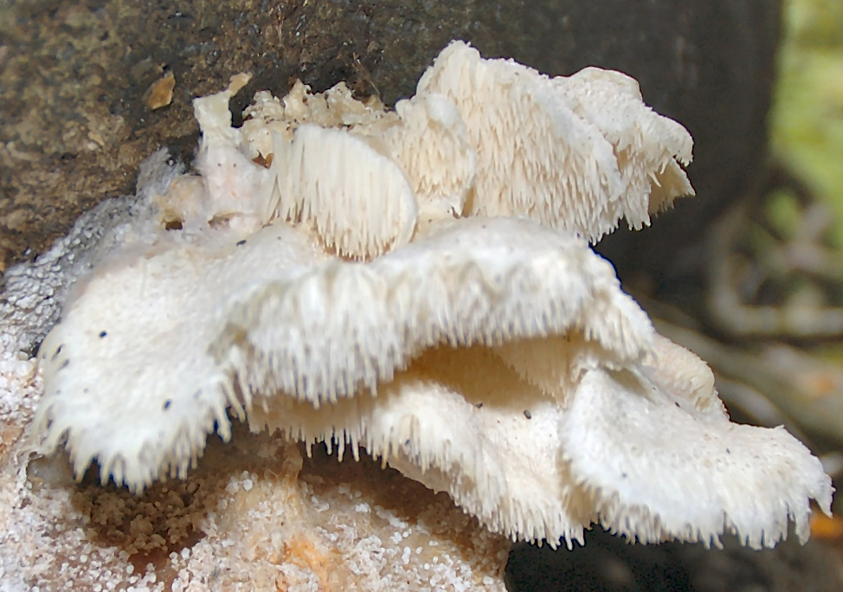
In 2005 Martyn Ainsworth tutored a “Talk and Walk” session for our group in The Beeches based on fungal indicator species to be found on Beech in ancient woodland in Britain. The indicator species approach - looking for a small number of distinct species that, collectively, point to the importance of sites for fungal conservation - had proven effective in classifying ancient Beech woodland in continental European countries like Denmark and Estonia. Martyn's work showed that it works equally well in southern England, with sites known to be important from extensive past research, like Windsor Great Park and the New Forest, scoring high on the indicator species scale. Burnham Beeches is well known as a distinguished ancient Beechwood site but it had not been studied as much as Windsor or the New Forest. Martyn's recent work showed that the presence of these key indicator fig.42 Hericium cirrhatum Burnham Beeches 8 Oct 2005 (DJS)
species placed
Burnham Beeches, in Buckinghamshire, well up the scale and of national, possibly international importance for fungal conservation. (More recently, he has found Langley Park, another Bucks. site, to also be important on this basis).

One of the many interesting and rare species we learnt about and were shown at Martyn's Talk and Walk in 2005, was Hericium cirrhatum, (fig.42) previously Creolophus cirrhatus (Tiered Tooth), an impressive toothed white bracket which I had previously seen at a couple of other Chiltern sites. Martin suspects this species never appears twice on the same log, and certainly my limited experience corroborates that, although I did come across it at a new site last autumn at The Beeches.

Another rarer Hericium species which I had long wanted to see, namely the stunningly beautiful H. coralloides (Coral Tooth), had not been discovered at this site at the time of Martyn’s talk, although he strongly suspected it ought to be here as it appears fairly frequently in the New Forest. Sure enough it turned up a year or so later, found by Head Warden Helen Read and later confirmed by Martyn. This was great news, but unfortunately for me I missed out and had still never seen it!

Then last September when driving through The Beeches I spotted three large white lumps sprouting from an old pollarded Beech trunk. Screeching to a halt to have a closer look, I discovered the lumps were indeed tiered with impressive long creamy cascades rather like a frozen waterfall, and, although the fruitbodies were mainly well above head

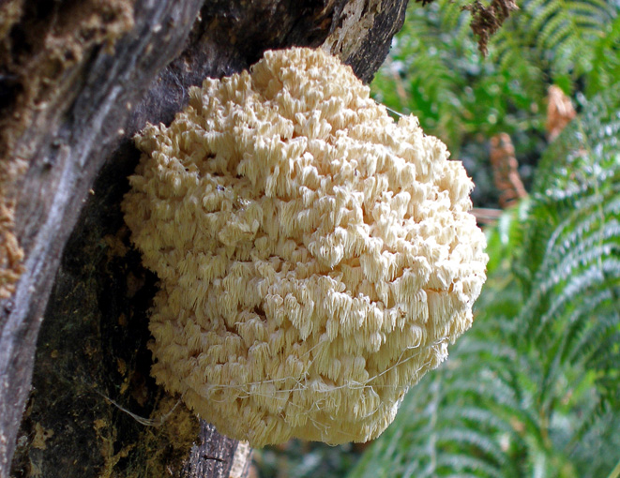

fig.43 Hericium coralloides Burnham Beeches Sep 2007 (PC)

height one was low enough to allow a photo (fig.43 above). On contacting Martyn and Helen I discovered this was the self-same trunk on which it had occurred before. Two more fruitbodies appeared during the next few weeks, so in all it was fruiting for well over a month – a wonderful sight and one that I was all the more thrilled with for
having found it for myself.

Now all we need to complete the trilogy at Burnham Beeches is to find the much rarer and elusive Hericeum erinaceum (Bearded Tooth) here, a species of particular beauty which is common enough in America to be collected for eating and is in fact now produced there commercially. I hoped I might find it on a birding trip to Florida last November, but no such luck.

THE DECEIVERS REVEALED

When first starting out along the fascinating and somewhat confusing voyage of discovery which foraying and mycology can often become, there are certain milestones along the way which can cause the beginner – and indeed the more experienced! - to doubt if they have what it takes to progress further down the road. What ever stage of expertise we may have reached, all of us remember that sinking feeling of utter stupidity and embarrassment when told for the umpteenth time by a rather bored-sounding but patient leader “Surely that’s just Russula ochroleuca / Stereum hirsutum / Piptoporus betulinus / Panaeolus foenisecii / Pluteus cervinus ……..….?” I often find myself thinking: “How many more times am I going to make a fool of myself over that species?” The answer, of course, is “Probably lots more!” The infinite variety, subterfuge and deception with which fungi seem to be able to trick us mere mortals is very humbling. So if you consider yourself a beginner, don’t despair, you’re in good company: even the most highly respected field mycologists will occasionally be taken in, if only momentarily, by such as the very common Laccaria laccata in one of its guises – after all, that species was not given its English name of The Deceiver for nothing.

So what’s so deceptive about it? Well, it’s a bit like the chameleon of the mushroom community: it changes colour; and not only that: its sister, L. amethystina, does too! What a pair, you can almost imagine them chuckling away with satisfaction every time a forayer pounces on one thinking it’s going to be something interesting, only to turn it over, then sigh with disappointment and drop it dismissively in the dust! Joking apart, there’s a significant clue to seeing through their disguise in the previous sentence, did you spot it? All, I hope, will now be revealed.

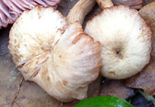
The key to the colour change which occurs in the cap of this genus, and indeed some others, lies in their lack of ability to retain moisture when exposed to sunlight and/or
dry conditions, for which the technical term is hygrophanous. (Hygro- in Greek means damp, moist, and hygrophanous literally means translucent when wet, becoming opaque when dry.) Thus when conditions are nicely moist and shady and the material is fresh, L. laccata has a subtly orange-rust cap, slightly translucent-striate and shiny (fig.44 below) reminiscent of maybe a Galerina or
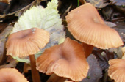

fig.45 Laccaria laccata faded caps (PC)

Tubaria; but given a warm day or some sunlight this quickly fades, becoming dry, slightly scurfy and almost white (fig.45, above) reminiscent of maybe a Psathyrella or Clitocybe. Note, however, the characteristic central depression and slightly crinkled margin apparent in both states also remnants of the
fig.44 Laccaria laccata fresh caps (PC)

original colour are still just visible at the margin in the faded specimens.

Now for the clue to identity at which I hinted earlier, a diagnostic feature of this genus which remains unaltered by the conditions: the gill colour. Turn your specimen over, whether its cap is moist and nicely coloured or dry and faded, and the widely-spaced pink gills are the instant give-away that you have a Laccaria and not one of the other four or possibly more genera, in fact the flesh-pink gills of a fresh fruitbody
become a “bluer” pink as the cap fades, making for a striking contrast between topside and underside. See figs.45 and 46, below, for comparison. "But others have pink gills too” I hear you say. Yes indeed, both Pluteus and Entoloma have pink gills when mature, but Pluteus occurs on wood, not soil or leaf litter, and the gills are very crowded with a different attachment to the stipe, and Entoloma although sometimes occurring in similar habitat also never has gills as widely spaced as those seen here. If you don’t feel confident that you can safely differentiate, try this season to familiarise yourself by repeatedly picking up this common species and looking underneath – I guarantee you will soon be able to spot if in fact you’ve collected something different.
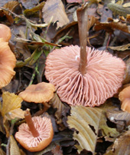
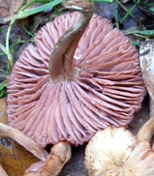
fig.46 Laccaria laccata fresh gills fig.47 Laccaria laccata faded gills (PC)

Now for the sister species, the beautifully coloured Laccaria amethystina predictably known as the Amethyst Deceiver. Although L. laccata is abundant everywhere under deciduous trees, often growing in troops, L. amethystina is in some years almost absent from the woodland floor but can also be very common, its occurrence seems to be unpredictably variable. (So nothing new there, then!) One would think its colour would make it conspicuous, but actually it is deceptively well camouflaged and often seems to frequent darker corners than its ubiquitous sister, although its cap colour will fade just the same in dry weather. When fresh the whole fruitbody boasts a deep amethyst purple, but only the gills retain this, although they may become a bit paler as the drying process kicks in (fig.48 next page, top left). There is another fairly common species around in similar habitat which one could easily confuse initially with ours, because the cap colour of Inocybe geophylla var. lilacina (fig.49 next page, top right) can sometimes be almost identical to L. amethystina. There are, however, many differences once one starts examining with care, but one obvious one to look out for in the field: you guessed it, turn it over and check the gill colour!

BRITISH MYCENAS – BRIEF DESCRIPTIONS

A couple of years ago I set myself the task of compiling a compendium of notes to help me get to grips with identifying a few more of the genus Mycena down to species – something which had long been bugging me because my skills at doing so seemed
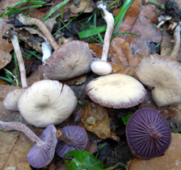
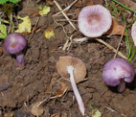

fig.48 Laccaria amethystina (PC) fig.49 Inocybe geophylla var. lilacina (PC)

limited to just a handful of the commoner species and I felt I should be doing better.

This is a large genus - numbers, not size! - with over seventy species known to be British to date. With regard to available literature, there is excellent coverage in English at the specialist level in the two volumes by Maas Geesteranus, described in the Guide to the Literature of British Basidiomycetes as the "bible for all Mycena studies", but like so many specialist books it unfortunately went out of print and, in any case, its rather complicated organisation I found to be less than user-friendly. The series of articles by Emmett in the Mycologist also provide useful cover to many of the British species but the separation into six articles makes this less convenient than it might be; his keys derived from these were distributed at a workshop in 2003 are also invaluable but do have their limitations as some species are omitted, and anyway they are not generally available. The popular “Fungi of Switzerland” series has good although not comprehensive cover in volume 3, but more recently a large and lavishly illustrated book in Italian (but with keys also in English), “Mycena d’Europa” by Robich , has been published, although even this omits a few British species. This I bought, and it was really this which inspired me to take on the challenge: now at last I had all the macro- and microscopic detail to hand, albeit in Italian, together with excellent photographic illustrations. Like many of us Brits I’m no linguist, but technical terms are often not that different in Italian, and with the aid of a dictionary and some inspired guessing one can make a reasonable stab at the descriptions too, and of course the photos and line drawings are invaluable.

I started by taking the species list in alphabetical order from the Checklist of British and Irish Basidiomycota, then using information gathered from Robich, Nordic Macromycetes, Arenson’s key, Emmett’s key, Fungi of Switzerland, Phillips, I put together a few lines on the salient features for each species followed by a basic line drawing of its cheilocystidia and spore shape. I then devised a simple code to speed up one’s search, using differently coloured boxes for habitat and size highlighting the species names – hours of fun!

It remained in that format for a year or so until I got the idea that photos of the cheilocystidia from fresh material could be of much more use than my attempts at line drawings, so I rejigged it and added these in as they became available although for obvious reasons this took a considerable time and is an ongoing process entirely dependent on finding and hopefully successfully identifying as many species as possible. To date I have over one third photographed although some are not great and need replacing as opportunities arise, and the remainder now have better quality cheilocystidia reproductions. Eventually I may well include some macro photos as well, but for now what it needs is using by others apart from myself to iron out errors, problems, etc, in fact to see if it’s useful. Richard Iliffe had kindly gone through it and
made some helpful suggestions and improvements, and I would now welcome more
feedback – having come this far I might as well get it as good as I can.

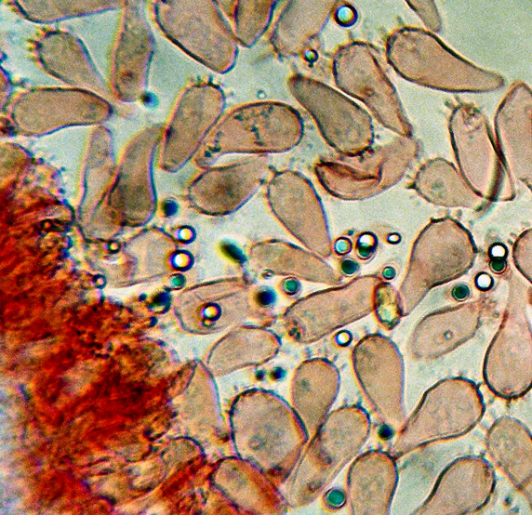
I am happy to email anyone a copy, although you will need a colour printer; it comprises twelve A4 pages with six or seven species on each. Please get in touch if you would like one. Here is an example, with lay-out and font of necessity rather condensed to fit here.

arcangelianaOn deciduous (occ. conifer) decayed fallen trees/
branches/ moss -covered trunks, clustered habit. Cap to 2cm,
dull sulphur-yellow with olive-greenish tones; gills whitish
decurrent, pinkish with age; flesh lemon yellow, stipe with
lilac tinge (young), rigid; iodoform smell (young), rigid; iodo-
form smell when contained/ drying. (Filipedes – am. spores,
hyaline, sub-globose (fatter than in similar metata); cheilos to
55µm, pyriform with thin brushcells, some with no“stem”;
numerous pleuros, similar.)

M.d’E p147; B&K no 319; A.A. 45, 79, 80; Cetto no 2366; Phil p81

ANIMAL, VEGETABLE OR FUNGAL?

Have you ever come across strange beasties whilst gazing down your microscope in search of spores and the like? One quite often finds creatures of one kind or another in a gill preparation, but these two really stopped me in my tracks and made me reach for the camera: I could hardly believe my eyes and had absolutely no idea what they could be. Would you have known? Have a guess, then turn to the back page for the answers. My thanks to Geoffrey Kibby who identifed the fairy tennis racquet
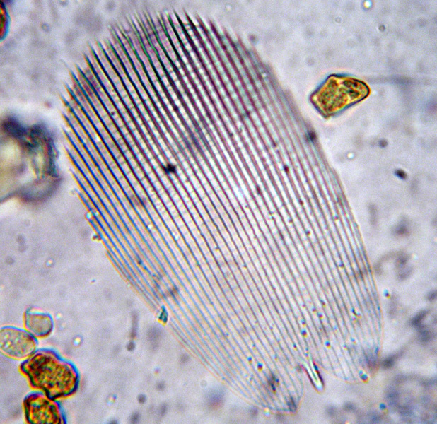
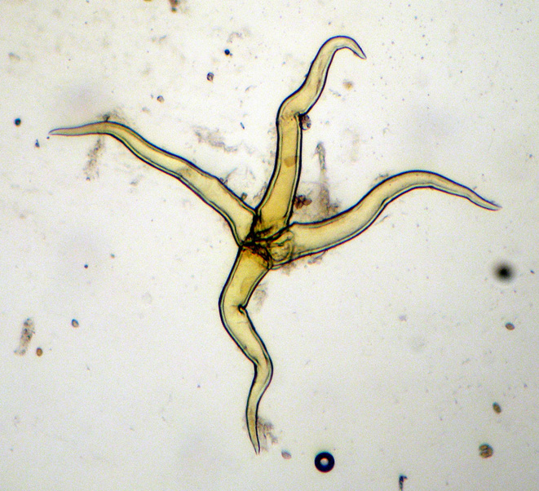

fig.50 Mystery object no. 1 (PC) fig.51 Mystery object no.2 (PC)
(fig.50 above left) accompanied by three nodulose Inocybe spores about 10 microns long which give an idea of scale, and to Peter Roberts for the Isle of Man symbol with the extra leg (fig.51 above right), this magnified about x 100.

If you have photos of other similarly intriguing puzzles I would love to have them for next year’s newsletter, so do please get in touch.

FUNGUS FEASTING

Last year I omitted this topic from the Newsletter due to pressure of space, but I know that many people are interested in collecting for the pot, in fact it’s often this aspect of studying fungi which fires the interest in the first place, as it was with me. So apologies to the purists among you, suffice it to say that my purpose here is to include something of interest for all.

CHICKEN OF THE WOODS WITH RICE
by Joanna Dodsworth

This is a simple, as well as a delicious, recipe. Use chicken or vegetable stock if you have it home-made, or else a very good quality stock cube. This year we found Chicken of the Woods in Whitecross Green Wood in mid-May. It happened to be in a spell of quite dry weather, but Laetiporus sulphureus (see front cover) seems to be able to grow in dry conditions, feeding as it does on water stored within large volumes of dead wood.

2 shallots finely chopped
2 oz / 50g butter
2 cups Chicken-of-the-woods cleaned and diced into half–inch cubes
200g rice: brown or wild
1.5 pints stock

Saute the chopped shallots over medium heat in two tbsps. of the butter for 5 mins. or until transparent. Add mushrooms and saute for another 10 more mins. In another pan melt the remaining butter, add rice and saute for 5 mins. Combine with the mushroom mixture and stock. Season, cover and bring to the boil. Simmer for 20 mins.

This fungus has excellent texture, really quite like cubes of white chicken meat, and the flavour, though delicate, is quite distinctive; hence it also makes a good stew. Add the cubed cleaned fresh fungus to any casserole half an hour before serving. Particularly good with pork or beef. Any surplus fungus can be chopped, fried lightly in butter, and frozen.

[NB Never eat this species raw – make sure it’s thoroughly cooked. It has been known to cause gastric upsets, so approach with caution the first time you try it! Only consider eating really young and fresh material, and don’t collect any found growing on Yew. If you have a suitable stump in your garden, there are commercial kits to grow your own available on the web, where you can also find plenty of recipes for this and other edible species. Editor]
SWEET OR SOUR BEEFSTEAK?
by Roger Wilding

Have you eaten Beefsteak Fungus (Fistulina hepatica) (fig.3 page 7) and if so, did you agree with the “good to eat” reputation it has? The first time my wife and I tried it, we were most disappointed. We found it had a strong sour taste, as if it had been soaked in vinegar. I then read somewhere that soaking the fungus in milk made it much more palatable, so the next time we picked a Beefsteak Fungus, we decided to put the milk treatment to the test.

Having removed the tough parts of the fruiting body where it had been joined to its Oak host, I cut the red juicy flesh into slices and submerged them in a dish of milk. Having left the slices of fungus to soak for two hours, I discovered that the milk had absorbed most of the red colouring from the fungus, leaving the latter looking a lot less like raw flesh. The milk was discarded and the fungus cooked gently in butter for just under ten minutes. The result was a tasty meal.

Despite finding a way to enjoy eating Beefsteak Fungus, I always feel guilty collecting this species unless there a several fruiting bodies present. Many specimens I can pass by as being too immature or past their sell-by date for collecting. Even when I see one just perfect for a meal, I think it is a shame to pick it because the next person to find it might also enjoy seeing or photographing it. So in many cases the fungus gets left as I found it. Later in the day, I start to wonder whether that next person did the same as me, or did he just cut or break off the fungus for the pot?

How does one cut off the fruiting body of a fungus at a time when people are demanding an automatic prison sentence for carrying a knife? Will we see a growth in the number of fungus groups inside our prisons as they fill up with mycologists?

[Do you have a favourite recipe or any other tips on this subject you would like to share? Would you like more on the dangers and delights of edible fungi, where to find it, what to beware of? In fact, what else would you like this newsletter to contain? Any feedback, suggestions, contributions and photos would be most welcome. Editor]

INOCYBES, PLEASE!

As some of you may know, I like to specialise in the genus Inocybe, and together with Alan Outen am planning a weekend workshop for October ’09. To this end we are now updating our keys and are keen to be able to examine as much fresh material to help us in this task. We would be most grateful to receive any nice collections of Inocybe you may chance upon during the coming season – well, maybe not I. geophylla or I. asterospora, i.e. the common ones. Although putting fresh specimens in the post may seem strange, it is necessary to work on fresh collections with this genus because the microscopic detail does tend to deteriorate on drying, and also it’s the fresh macro characters which make any key user-friendly. Do please give me a ring or an email to make sure I’m going to be around and for tips on packing, and I’m happy to refund postage. A couple of points on collection; it’s important to note the trees – all of them – near the fruitbodies, and also to avoid handling the stipe as much as possible, making sure you don’t lose the base: unfortunately identification is well-nigh impossible unless the stipe, the delicate cells on its surface and its base are intact. Thank you very much, and I look forward to hearing from you.

TREES - LATIN TO ENGLISH

I had a request from Justin Long for this list earlier in the year, and it also fits in neatly with my regular Newsletter pattern of including some article with a Latin / English theme. Tree recognition is vital for any serious forayer, as so many of the woodland fungi species grow in association with a particular tree; in fact, having located any fungus near a tree it should really become routine to look up and make a note of not just the nearest tree but also those around it which may be bigger and spreading roots from which your specimen could be growing. It is worth bearing in mind that the span above ground of any tree is often equally mirrored below ground, and it is not unusual to find mycorrhizal species (those known to grow in symbiosis with plants, of which Amanita, Boletus, Hebeloma, Inocybe, Lactarius and Russula are classic examples) growing towards the perimeter where the young tree roots are maybe particularly active.

Mycorrhizal fungi is a vast topic into which maybe Derek or I will attempt to delve next year, but for now the list:

Abies – Fir Picea sitchensis – Sitka Spruce
Acer campestre – Field Maple Pinus nigra var. maritima -Corsican/Black Pine
Acer platanoides – Norway Maple Pinus sylvestris – Scots Pine
Acer pseudoplatanus – Sycamore Platanus hispanica – London Plane
Aesculus – Horse Chestnut Populus alba – White poplar
Alnus – Alder Populus canescens – Grey Poplar
Arbutus – Strawberry Tree Populus nigra – Black Poplar
Betula pendula – Silver Birch Populus tremula – Aspen
Buxus – Box Prunus avium – Wild Cherry
Carpinus – Hornbeam Prunus domestica - Damson
Castanea – Sweet Chestnut Prunus laurocerasus – Cherry Laurel
Cedrus – Cedar Prunus padus – Bird Cherry
Cornus sanguinea - Dogwood Prunus spinosa - Blackthorn
Corylus – Hazel Pseudotsuga menziesii – Douglas Fir
Crataegus – Hawthorn Pyrus communis – Pear
Cupressus – Cyprus Quercus borealis – Red oak
Euonymus – Spindle Quercus cerris – Turkey Oak
Fagus sylvatica – Common Beech Quercus ilex – Holm Oak
Ficus - Fig Quercus petraea – Sessile Oak
Fraxinus – Ash Quercus robur – English Oak
Ilex – Holly Rhamnus – Buckthorn
Juglans – Walnut Salix alba – White willow
Juniperus – Juniper Salix caprea – Goat Willow
Larix decidua – European Larch Salix fragilis – Crack Willow
Laurus – Bay Sambucus – Elder
Malus sylvestris- Crab Apple Sequoia – Redwood
Morus nigra – Black Mulberry Sorbus aria – Whitebeam
Nothofagus – Southern Beech Sorbus aucuparia – Rowan/Mountain Ash
Picea abies – Norway Spruce Sorbus torminalis – Wild Service Tree
Syringa – Lilac Tilia platyphyllos – Large-leaved Lime
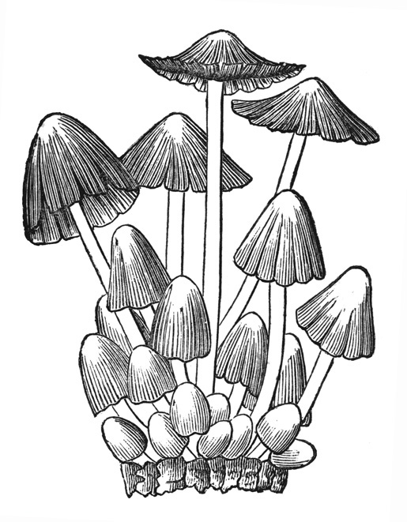
Taxus – Yew Ulmus glabra – Wych Elm
Tilia cordata – Small-leaved Lime Ulmus procera – English Elm
Tilia europaea – Common Lime

MOTIF ON THE FRONT COVER

As this is our 10th anniversary year as a Fungus Recording Group, you might like to know the origin of the motif used on
our literature since we began (shown to the right). This is a line drawing of Coprinus (as it then was) micaceus copied from M.C. Cooke's "Handbook of British Fungi". I chose a line drawing
since we could only print in black and white and, as the book was published in 1871 and Cooke died in 1914, it was free of any
copyright (but only by 14 years)! Derek Schafer

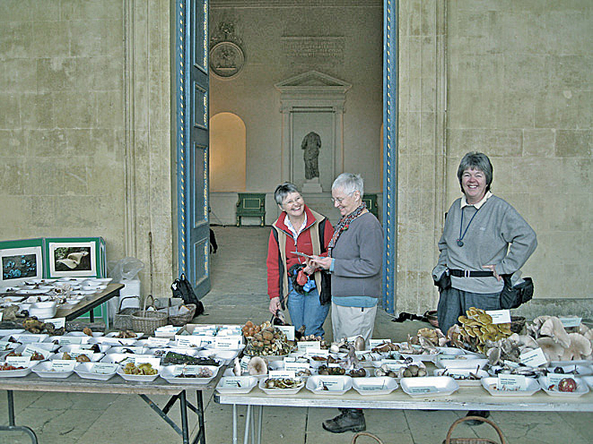

Fungi on display at Stowe Landscaped Gardens Nov 2007 with
Jenny Schafer, Joanna Dodsworth and Penny Cullington (DJS)

Penny Cullington, 24 Willow Lane, Amersham, Bucks. HP7 9DW Tel: 01494 721979
e-mail p.cullington@ntlworld.com

Derek Schafer, Duck End House, Hawleys Lane, Whitchurch, Bucks. HP22 4LB Tel: 01296 640923

e-mail fungi@bucksfungusgroup.org.uk

